AWESOME ELEMENTARY SCHOOL
Check-In/Check-Out Manual

TABLE OF CONTENTS

CICO Intervention Guideline
Purpose of CICO clearly described
Overview of the CICO program
Overview of CICO routine/process
Check in/out staff and location identified (including substitute support)
Student Selection Process
- Data decision rules for screening
- Timeline for access to intervention
Daily Progress Report
- Generic point card linked to positive SW Expectations
- General check-in times identified
- Clearly defined expectations for how to rate student behavior
- Clearly defined process for providing teacher feedback to student
Acknowledgment & point trading system
- Range of incentives
- Documentation of how student progress toward rewards is kept
- Documentation of timeline for delivery of student rewards
Training & Orientation Materials
- Students
- Whole staff overview (e.g., description of CICO, how to access)
- Teacher support when student is on CICO
- Parent Letter
- Substitute teacher information/materials
- Plans for supporting fidelity of implementation
Method for Monitoring Student Progress
Additional Materials

INTERVENTION GUIDELINE

Intervention | Description | School-wide Data: Entry Criteria | Data to Monitor Progress | Exit Criteria
Check-In/Check-Out

Rationale
The purpose of CICO is to

Overview of CICO (Routine & Practices)
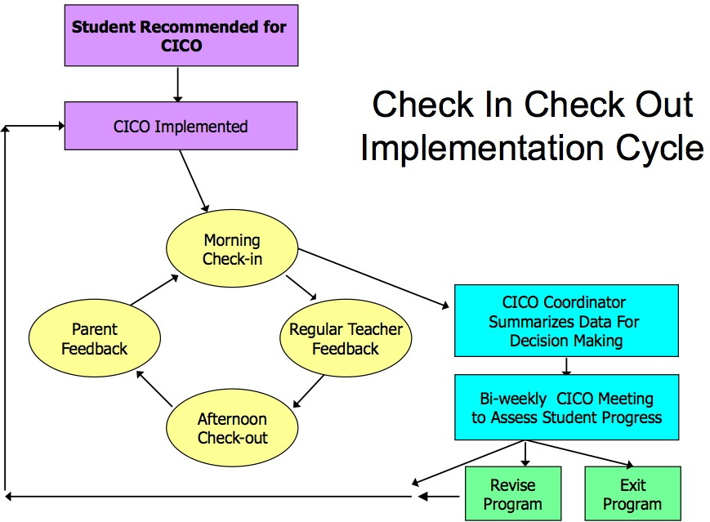

CICO STAFF
Check-in/Check-out Coordinator:
Description:
STUDENT SELECTION PROCESS

Data Decision Rules: Describe Entry Criteria from Intervention Guideline

DAILY PROGRESS REPORT

Place DPR Example Here

ACKNOWLEDMENT SYSTEM

Describe how students will be acknowledged for participating and meeting goals.

TRAINING & ORIENTATION MATERIALS

Staff Training Materials
http://pbistier2.weebly.com/uploads/1/2/7/0/12709910/cico_saff_training_template.ppt
Student Orientation Materials

Parent Orientation Materials

Substitute Teachers Orientation Materials

MONITORING STUDENT PROGRESS

ADDITIONAL MATERIALS

