The High School Behavior Education Program,

HS-BEP



Jessica Swain-Bradway,

University of Oregon
Judy Kerner, and Melanie Morrison,
Churchill High School



Table of Contents
Summary Sheet for HS-BEP……………………………………………………………… | 3
The Big Idea ……………………………………………………………………... | 4
Secondary level interventions: Features………………………………………………….. | 5
Combining Academic and Social Supports………………………………………………. | 5
High School Behavior Education Program, Overview….…………………….. | 8
Enrollment Criteria for HS-BEP……………………………………………...................... | 9
HS-BEP Team, Roles and Responsibilities…….…………………………………………. | 10
Identification Protocol for Secondary Level Support …………………………………….. | 13
TABLE: Summary of Student Needs, Supports Available, Information Needed………… | 14
Request for Assistance form………………………………………………………………. | 15
FLOW CHART: Identification of Students for Secondary Level Supports……………… 14 | 18
Post nomination protocol………………………………………………………….............. | 19
FLOW CHART: Academic and Social Support Cycle…………………………………… | 20
Setting, Tracking, and Rewarding Academic and Social Goals…………………............... | 21
Graphing Examples ……………………………………………………………………… | 23
Using SWIS-CICO ………………………………………………………………………. | 25
Rewards……………………………………………………………………………............ | 30
EXAMPLE: Rewards Bank……………………………………………………………….. | 31
Fading, Follow-up, and Exit Criteria…………………………………………….............. | 32
Data Collection, Review, and Use for Decision-Making…………………………………. | 36
Modifications……………………………………………………………………………… | 39
Training Staff and Orienting Students…………………………………………………….. | 40
Obstacles and Potential Solutions………………………………………………… | 42
HS-BEP Teacher Plans …………………………………………………………. | 43
HS-BEP Classroom Guidelines…………………………………….................................... | 44
Scope and Sequence of Academic Skills………………………………………................. | 45
Lesson Plan Format……………………………………………………………….............. | 46
Daily Entry Task, defined and examples………………………………………………….. | 47
Lesson Plans
School-wide expectations……………………………......................................................... | 48
HS-BEP Card Usage………………………………………………………………............ | 50
TABLES: HS-BEP Card Responsibilities………………………………………………… | 52
Goal Setting……………………………………………………………………………….. | 56
Graduation Plan…………………………………………………………………………… | 61
Planner Use………………………………………………………………………............... | 65
Notebook Organization…………………………………………………………………… | 68
Test taking………………………………………………………………………………… | 71
Study Strategies…………………………………………………………………………… | 73
Tracking Progress Using Technology…………………………………………….............. | 75
Tracking Progress…………………………………………………………………………. | 81
Sample Grading Rubrics………………………………………………………….............. | 84
HS-BEP Grading Policy……………………………………………….............................. | 85
EXAMPLE: HS-BEP Card………………………………………………………………. | 86
References………………………………………………………………………………… | 87
High School Behavior Education Program (HS-BEP): A Secondary Level Intervention

Coordinator:

- Purpose
  - To provide a daily check in, class by class checks, and check out with teachers
  - To provide organizational, social and academic prompts
  - To establish regular communication with families of students participating in HS-BEP
  - To build organizational skills
  - To provide assistance for homework completion
- Identification of student participants
  - Summer school programs
  - Request for assistance nomination
  - Student who is failing classes due to missing or incomplete work
  - 2-3 Office Discipline Referrals
- Procedures for participating in the intervention
  - What the staff do:
    - Provide student with a brief, positive welcome, provide rated feedback and positive comment at the end of class.
  - What the students do:
    - Checks in and out with HS-BEP coordinator every other day, establishes specific academic or social goals, uses the card throughout the day as a prompt, solicits teacher rating at the end of each class period.
  - What the families do:
    - Prompts the student to share the HS-BEP card, provides positive feedback, signs the card, reminds student to return card to school. The parent does not use the card to correct the student again, but simply uses the card as a tool for starting a conversation about the school day.
  - What the coordinator does:
    - Orients student to intervention, manages HS-BEP card data, checks in and out with each student every other day, communicates with staff about student HS-BEP card status.
- Procedures for training staff, students, family
  - Staff training at the beginning of the year with boosters in winter and spring.
  - Student handbook provides a description of the program
- Data system for monitoring student progress
  - HS-BEP coordinator responsible for HS-BEP card data entry (using SWIS-CICO), learning activity grading. All data to be updated once every 48 hours.
- Decision making cycle
  - Student progress monitoring
    - HS-BEP coordinator enters and summarizes data for twice monthly Behavior Support Team meetings.
    - Guidelines for concern:
      - Significant departure in HS-BEP card points, grades, Office Discipline Referrals, or attendance.
  - Fidelity and effectiveness of secondary level intervention
    - Behavior Support Team review overall student progress at twice monthly meetings.
    - Behavior Support Team completes fidelity check at least twice per year, fall and spring.
The Big Idea

High school students identified as having at risk academic or social behaviors have a difficult task ahead. A great deal rests on their ability to successfully earn a diploma. Increased rates of unemployment, criminal involvement, greater health problems and dependence on welfare and other public assistance programs are among some of the significant risks associated with the failure to earn a high school diploma (Day & Newburger, 2002; Rumberger, 2001). Unfortunately, there is a strong relationship between academic failure and problem behaviors (McIntosh et al, 2008; Roeser & Eccles, 2002) and students who struggle with both academic and social behaviors are much more likely to drop out of school than their peers (Allensworth & Easton, 20065; Jerald, 2006). Addressing social behavior without supporting academic success is often ineffective.
In recognition of the interrelatedness of academic and social problems, secondary level interventions must address both of these areas concurrently. The level of support necessary to help students complete high school must a) establish regular, positive contact with teachers, b) decrease the instructional “punishers” a student experiences in the day to day interactions, and c) provide specific skills to improve academic engagement and success.

The HS-BEP is a secondary level intervention for high school students designed to:
- Decrease the instructional “punishers” a student is experiencing by providing:
  - explicit instruction in organizational and self-management skills, and
  - homework completion assistance
- Increase positive adult interaction and specific behavioral prompts through use of the HS-BEP Card, a daily behavior report card.

HS-BEP is for students who are not responding to universal supports. It is a two-fold intervention consisting of (a) concurrent participation in an academic support class, Academic Seminar, that follows the HS-BEP curriculum and (b) participation in a behavioral report card, the HS-BEP card. HS-BEP targets freshman and sophomore students who meet the following criteria:
- Student is engaging in problem behavior, but no “crisis” behaviors.
- Improved structure would help student succeed.
- Student may lack organizational skills.
- Student is placed at appropriate instructional level for academic courses (math, reading, history, etc).
- Student is not achieving at least a C in core classes due to lack of, or poor quality completion of: class/ homework, tests, or class projects.

The rest of the handbook outlines the administrative and curricular components of the program. First, some general information about secondary level interventions is provided as a frame of reference.

Secondary Level Interventions

The HS-BEP program builds off the universal school-wide expectations. The most well implemented universal supports are not always sufficient to address the needs of all students within a school. Often there are small groups of students or individual students who require more intense, individualized supports. Schools implementing School-Wide Positive Behavior Supports (SW-PBS) may find that as many as 15%-13% of the student population require more intense supports in order to be academically and or socially successful.

Features of Secondary Level Interventions

HS-BEP is a secondary level intervention that provides an increased level of support for small groups of students considered “at-risk” for negative school outcomes including academic failure and disciplinary problems. Secondary level interventions have the following characteristics:

- Efficient
  - All staff know about the intervention
  - Minimal time investment by faculty / staff
  - System for linking academic and behavioral performance
- Continuously available:
  - Administrative support and intervention components firmly in place within a school
- Skills are explicitly taught, used and reinforced
- System for increasing structure and predictability
- System for increasing positive adult feedback
- System for increasing home / school communication
- Ongoing data collection for decision making

Combining Academic and Social Supports

Alone, the Academic Seminar class targets academic difficulties. Students receive explicit instruction in organizational and self-management strategies, and assisted homework completion to help increase their academic success. Adding the behavior report card, a Check-In Check-Out cycle, to the Academic Seminar class provides social supports for students who are also experiencing behavioral difficulties. Both the Academic Seminar Class and Check-In Check-Out cycle together constitute the HS-BEP.

The combination of academic and social supports is necessary due to the interrelatedness of problem behavior and academic failure and this high stakes associated with completion of high school. Students experiencing problem behaviors often experience concurrent academic difficulty (McIntosh et al, in press). The combination of these problems increases students’ likelihood of dropping at a higher rate than their peers who experience difficulties in either one of these areas (Jerald, 2006).

The subsequent sections of this manual will provide an overview for the HS-BEP. Following the overview, plans for implementation are presented in an easy to read format, including (a) check lists for student, family, teacher and coordinator responsibilities, (b) lesson plans and (c) examples of student worksheets.

The features outlined serve as a framework for implementation. Teachers should feel free to create learning activities around the critical features of the curriculum outlined in the lesson plans. Behavior Support Teams and or teachers may find the need to make modest modifications to fit school contexts or student needs. Regardless of modifications the focus of the intervention is to decrease the difficulty of academic task by providing explicit instruction in organizational skills and homework completion while increasing self-management skills and contingent reinforcement from teachers through use of the HS-BEP Card.

HS-BEP
Academic & Social

Tertiary Level Supports
Secondary Level Supports
Academic Support Class
Read Right, Math Assistance, Homework Club
Universal supports
Advisory / Study Hall
School-Wide Expectations
Wrap around / Person Centered Planning

Individual Support Plan

Functional Assessment
Three Tiered Model of School-Wide Positive Behavior Supports
Freshman Seminar

HS-BEP, Overview
The Academic Seminar Class is a 45-minute period designed to decrease the difficulty of academic tasks through explicit teaching of academic skills and supported homework completion. The class has a low student to teacher ratio, 12:1 max. This allows the HS-BEP teacher to fully support the students in achieving the goals of the class. The overarching goal of the class is for students to become fluent in the organizational and self-management skills required for successful completion of class work, homework, tests, and projects. The relevance and applicability of the organizational skills extend past high school to post-secondary, real-world settings.

As much as possible the scope and sequence of the specific academic skills should be organized to mirror the academic demands of the general school (such as exams, projects, etc.) so the skills learned in Academic Seminar can be applied to general content assignments. The HS-BEP curriculum focuses on the following academic activities:
  - Planner use and maintenance
  - Notebook organization
  - Goal setting for academic and social behaviors
  - Tracking progress
  - Test taking
  - Study strategies
  - Creation of a Graduation Plan

The learning activities in Academic Seminar focus on teaching students how to organize and prioritize academic tasks. A Daily Entry Task at the beginning of each Academic Seminar class period orients the students’ academic efforts for the 45-minute class period and helps them prioritize tasks for work completion after school or the next day. (For the HS-BEP Classroom Guidelines, see page 34)

The HS-BEP card is an additional component deigned to increase the structure and support of Academic Seminar. The HS-BEP card is for students who are engaging in more intense “at risk” behaviors that result in an office discipline referral (i.e. skipping class, repeated class disruptions, repeated latenesses, etc). The HS-BEP card is a behavioral report card that students use to remind them of their social behavioral goals and provides a schedule for recruiting teacher feedback. Students begin their day checking in with a positive, supportive adult. Throughout the day they receive positive, written feedback from their classroom teachers contingent on demonstration of school-wide expectations. The HS-BEP card concurrently functions to remind teachers to “catch” students engaging in positive behaviors and provide feedback acknowledging the positive behavior. The HS-BEP card is embedded into the daily classroom protocol of Academic Seminar. Depending on the level of students’ social needs they can participate in Academic Seminar with or without the HS-BEP card component.

The following sections will provide the critical features of (a) enrollment criteria, (b) curricular materials for HS-BEP, (c) teacher, student, and parent responsibilities, and (d) fading and follow-up procedures.

HS-BEP Enrollment Criteria


Teacher input into the identification process is critical to accurately assess a student’s present level of academic and social performance within the classroom setting. The screening process for summer school programs, as well as “concern” lists from middle school can provide appropriate information on students’ academic and social needs. Freshman students nominated for, or participating in the summer school programs should be considered for participation in HS-BEP.
During the school year teacher requests for assistance are the primary means of identifying freshman or sophomore students at risk of class failure. Grade level counselors may also make nominations based on review of mid-term or progress reports. HS-BEP most effectively meets the needs of students displaying the following characteristics:

- Student is engaging in problem behavior, but no “crisis” behaviors:
  - Occasionally skips class
  - Talking during teacher instruction
  - Failure to complete homework, class work, class projects
- Improved structure would help student succeed.
- Student may lack organizational skills:
  - Notebook, backpack is disorganized.
  - Student often misplaces or can’t find assignments
- Student is placed at appropriate instructional level for academic courses (math,
reading, history, etc).
- Student is not achieving at least a C in core classes due to lack of, or poor quality
completion of: class/ homework, tests, or class projects.
- Student responds positively to at least one adult in the school.

It is important to note that students displaying high risk behaviors will not adequately have their needs met by HS-BEP alone. Student supports to address high risk behaviors should include:
      - consultation from district behavior support specialist,
      - a functional assessment, and
      - cohesive supports provided by a number of faculty and staff within the school setting as well as parental/guardian involvement.

High risk behaviors that require immediate, cohesive supports include the following:
- substance abuse,
- high rates of skipping class and or school (more than 3 times per week),
- violent or aggressive behaviors (such as hitting other students, verbal harassment including sexually explicit language, etc),
- suicidal comments or suggestions


HS-BEP Team

As with other supports within the school system, the HS-BEP requires a team of school personnel to make data-based decisions regarding student identification and intervention modifications. The following section outlines a) team membership, b) team meeting criteria, c) HS-BEP teacher responsibilities, d) administrative support.

Team Membership
The HS-BEP team may be an extension, or sub-committee of the secondary support team within a school (Student Support Team, Intensive PBS Team, Drop Out Prevention Team, etc.). Below are suggestions for team members.

The most important feature of the HS-BEP team is the ability of the team to maintain the processes (identification, monitoring, data management, etc.) regardless of the make-up of the team. For example, depending on the current organization of job responsibilities, the school counselor or behavior support personnel may head up identification of students who are not responding to universal supports. The HS-BEP teacher or an Instructional Assistant may be responsible for data management.

Member | Role
Administrator | - Allocate resources, approve system level changes.  - Has working knowledge of school-wide, secondary, and tertiary systems already in place within the school.
Behavior support personnel | - Facilitates identification of students who are not responding to universal supports,  - Provides suggestions for modifications: intensifying, individualizing, combining supports, fading, etc.
HS-BEP teacher(s) | - Teaches the HS-BEP class  - Enters progress monitoring data (HS-BEP card data and classroom activity grades) every 24-48 hours.  - Provides twice monthly summaries of: students responding to the intervention, students not responding and requiring additional supports.  - Facilitates communication between content area teachers and HS-BEP team
School counselor | - Facilitates identification of students who are not responding to universal supports.  - Facilitates communication between content area teachers and HS-BEP team  - Facilitates communication across all three tiers of supports (Universal, secondary and tertiary teams).
Content area teacher | - Provide information about current instructional practices within content area classrooms.

Team Meeting Criteria

The HS-BEP team should dedicate a minimum of one hour every other week to discuss:

  - Newly identified students
  - Progress of current participating students
  - Next steps for non-responders
  - Progress of students who have been faded from the HS-BEP

Meetings should have an agenda and clearly defined roles within the meeting process: facilitator, time keeper, and note taker. The meeting roles are in addition to the specific responsibilities outlined above.

Decision rules for identifying students, modifying and fading supports for students are described in subsequent sections.

HS-BEP Teacher Responsibilities

A teacher delivering the HS-BEP may be a Special Education teacher, or content area teacher, who is perceived as socially reinforcing by the student population. This is important due to the history of school failure experienced by many students requiring the HS-BEP. Students must feel as though they can trust, and are supported by the HS-BEP teacher. This does not imply that the teacher is a “friend”, yet an adult in the school who provides explicit, consistent expectations, positive feedback, and relevant supports.

The HS-BEP teacher is directly responsible for:
  - Managing classroom behaviors,
  - Delivering academic curriculum,
  - Teaching students the Check-In Check Out cycle,
  - Morning check-in,
  - Afternoon check-out, and
  - Management of academic and social data.

The critical features of the HS-BEP classroom, including management and instructional strategies are described in the HS-BEP Classroom Guidelines, page 34.

The HS-BEP teacher may be a Special Education or content area teacher. Depending on the number of students the school intends to support in the HS-BEP class the teacher may have part or all of their FTE dedicated to the HS-BEP class. For example, a Special Education teacher may teach three sections of the HS-BEP, one section of basic math, and provide in-class support for a content area classroom.

Administrative Support

Administrative support is vital to the implementation of HS-BEP. An administrator will need to:
  - Allocate sufficient FTE, for both teaching and data management, to meet the student need within the building,
  - Determine which staff member(s) is qualified to teach the HS-BEP class,
  - Facilitate reorganization of systems and processes within the school to allow for ease of identification, progress monitoring, and data management.

Administrative support can also be crucial in building staff support of the HS-BEP. Above and beyond the administrative functions, visible, active support of the HS-BEP should be evident by:
  - Regularly scheduled HS-BEP team meeting times,
  - Regular attendance of the HS-BEP team meetings,
  - Approving, and or facilitating staff updates as part of staff meetings or school-wide emails

Identification Protocol: Secondary Level Support

- Students entering High School at the ninth grade level with a recommendation for participation in Summer School Programs are considered priority for participation in HS-BEP.

- Students displaying a need for additional academic or social supports during the school year must be nominated in writing by teacher, counselor or administrator.

- Nominating adult must complete a request assistance for the student in question.

- The request for assistance goes to a designated school personnel, who is part of the Behavior Support Team.

- The designated personnel will compile academic, attendance, discipline records, and IEP status information for the student(s) needing additional supports.

- The Behavior Support Team will hold meetings every two week to review requests for assistance.

- During the review, the Behavior Support Team will determine the level of support required and begin the home contact / student orientation process. Level of support includes the available interventions currently in place at High School:
      - Homework Club,
      - Read Right,
      - Math Support,
      - Academic Seminar (academic support only),
      - HS-BEP (academic and social support),
      - Anger Management class
      - Individual student contract, etc.

- A contact person is established for the student and family. If the student is on an IEP, the contact person is the case manager. If the student is not on an IEP a member of the Behavior Support Team becomes the contact person for the family and student.

See Flow Chart of Identification Process, page 17.

Student needs dictates the intensity and type of supports provided. See table below for general guidelines. PLEASE NOTE school personnel and family input is critical for making decisions about the most appropriate intervention for meeting student needs.

High School,
Example summary of student needs, supports available, and information needed

Student needs | Supports available | Information needed
Academic need only:  - Failing 2-3 classes based on missing or incomplete work | - Homework Club  - Academic Seminar | - Completed Request for Assistance  - Grades / Progress Reports  - Attendance records
Academic need:  - Failing classes due to lack of skills, placement change an option. | - SPED referral | - Completed Request for Assistance  - Grades / Progress Reports  - Attendance records  - IEP status  - Academic Testing information: Reading, math, etc.
Academic and behavioral need:  - Failing 2-3 classes based on missing or incomplete work  - 1-3 office discipline referrals | - HS-BEP | - Completed Request for Assistance  - Grades / Progress Reports  - Attendance records  - IEP status  - Academic Testing information: (reading, math, etc.)  - Office discipline records
High Risk needs:  - High risk behaviors requiring immediate assistance and multiple supports | - “Wrap-around” support organized by school counselor | - Completed Request for Assistance  - Grades / Progress Reports  - Attendance records  - IEP status  - Academic Testing information: Reading, math, etc  - Office discipline records  - Mental / physical health assessments –or- Physician report

High School, Request for Assistance

Student ____________________________________ Date ___________________
Grade __________________ SLC ____________ Counselor________________
Referral submitted by: _____________________________________________________

1. Student strengths: ______________________________________________________

2. Is the student qualified for Special Education Services? Y N

3. How many days has the student been suspended this year? ________
4. Please give an estimate of student’s academic progress in your classroom:
______________________ (class work)
______________________ (homework)
______________________ (test average)
Problem Behavior(s): Identify Top 3 Most Problematic Behaviors
___ Tardy | ___ Fight/physical aggression | ___ Disruptive | ___ Theft
___ Unresponsive | ___ Inappropriate language | ___ Insubordination | ___ Vandalism
___ Withdrawn | ___ Verbal harassment | ___ Incomplete work | ___ Other  _______________
 | ___ Verbally inappropriate | ___ Self-injury

What have you tried ? ____________________________________________________________

How has it worked? ______________________________________________________

Why do you think the behavior(s) keep happening? _____________________________

Referring teacher, do not write below this line, for Behavior Support team documentation only.

Relevant information has been reviewed: BY: __________________________
(SST, PBS, counselor, etc.)
⁯ grades ⁯ attendance ⁯ testing information

⁯ disciplinary records ⁯ other: ______________

Recommended for:

⁯ Academic Seminar ⁯ HS-BEP ⁯ Read Right ⁯ Math Support
⁯ Special Ed. evaluation ⁯ HS-BEP card only ⁯ Other ____________________
HS-BEP Eligibility Checklist

- HS-BEP is designed to meet the academic and behavioral needs of a small group of students who
are demonstrating, or demonstrated in 8th grade, academic and social behavior problems.
- Please complete the following checklist for students who are being considered for HS-BEP:
Student name_________________________________ Grade _____
Counselor___________________________________

The information documented on this form is based on:

 current status  recommendations from middle school

Has a request for Assistance been completed for this student? (Circle one) Yes No

Part 1: Academics and Organization
Improved structure would help student succeed. Yes No

Student may lack organizational skills: Yes No

Notebook, backpack is disorganized. Yes No

Student often misplaces or can’t find assignments Yes No

Student is placed at appropriate instructional level for academic courses Yes No
(math, reading, history, etc).

Student is not achieving at least a C in core classes due to lack of, or Yes No
poor quality completion of: class/ homework, tests, or class projects.

Part 2: Classroom Behaviors
Student responds positively to at least one adult in the school.* Yes No

Student is engaging in problem behavior, but no “crisis” behaviors:* Yes No

Occasionally skips class Yes No

Talking during teacher instruction Yes No

Failure to complete home/class work, projects Yes No

Other ________________________________________

Student has office discipline referrals for minor infractions Yes No
(skipping, minor disruption, etc.)

HS-BEP Eligibility Checklist

Eligibility Criteria

Academic Seminar: Student must meet all eligibility criteria in Part 1.

HS-BEP: Student must meet all the eligibility criteria in Part 1 and the first two questions in Part 2.

**If there are other considerations for including the student in HS-BEP
please explain here:

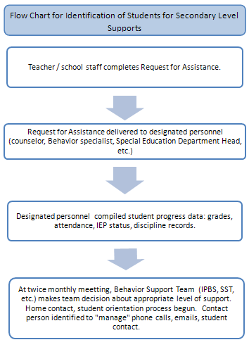
Post Nomination

- After appropriate supports are determined the contact person makes initial contact with the student and parents/guardians. The student and family is notified of the nomination and a meeting will be scheduled, a phone conference is appropriate if the family’s work schedule is an obstacle to meeting during school hours. The meeting will include positive language to explain:
  - The reason for the request for additional assistances.
  - The school supports determined by the Behavior Support Team as a best match for student needs.
  - The daily procedures of the school support (what it is, how the student participates, etc.)
  - A student contract for participation is completed.
  - Parental / guardian input and consent for participation is obtained.

- The Behavior Support Team, student and family member(s), will make a team decision about the level of assistance most appropriate to meet the student needs.

- Within three weeks of the request for assistance the student will start Academic Seminar, HS-BEP, additional academic assistance (Read Right, Math Support, Homework Club, etc.), or an individual contract depending on documented needs.

- The full orientation for student participants will be the responsibility of the individual intervention coordinators. For example, the HS-BEP coordinator will provide student participants with explicit instruction in the daily protocols of HS-BEP.

Academic and Social Support Cycle

Once the student has been identified for additional support in HS-BEP, and completed the orientation process, she / he can begin participating in HS-BEP. The following graphic models the cycle of participation:

Identification for participation in Academic Seminar, or Academic Seminar Plus
Meeting with student, parent/ guardian, Behavior Team representative – or- HS-BEP coordinator

Student Checks-in with Academic Seminar teacher
Picks up new HS-BEP card.
Completes learning activities in Academic Seminar.

Student attends HS-BEP class
Teacher rates behavior at the end of class.
Student retrieves HS-BEP card from the teacher.
Class –by-class check: Attends daily classes.
Hands HS-BEP card to each teacher upon entering the room.
Brings card home to share with parent/ guardian.
Gets home signatures
Repeats class by class cycle.
Returns card to Academic Seminar teacher the following class.
Checks out in afternoon with HS-BEP coordinator
Setting, Tracking and Rewarding HS-BEP Goals

School-wide expectations
Explicit instruction in the school-wide academic and social expectations is the foundation for the HS-BEP program. The academic and social skill building organized within the HS-BEP curriculum requires that students have a working knowledge of the behaviors that exemplify the Lancer HS-BEP school-wide expectations.

HS-BEP Card and school-wide expectations
When students have developed fluency in identifying examples and non-examples of school-wide HS-BEP expectations they can begin setting specific goals that will function to remind and guide them in meeting school-wide expectations. The HS-BEP card gives students the opportunity to work towards personal goals and receive feedback on meeting these goals. Step by step responsibilities for student, teacher and HS-BEP coordinator are outlined in the “HS-BEP Card Responsibilities” section.

Setting Goals
Setting social and academic goals is the basis for developing self-management skills in HS-BEP. Students need to increasingly gain (a) awareness of their own behaviors, and (b) build skills to manage their behaviors more effectively in the school setting. The goal for HS-BEP card for all students is to earn at least 80% of their daily points by following school-wide rules. How each student achieves this goal is entirely dependent upon the individual student. Individual students may need to work on a range of school behaviors, including but not limited to:
- Arrive to class on time
- Increase homework completion
- Decrease talk-outs
- Utilize the teacher web-sites to stay appraised of work completion

Explicit modeling and practice is necessary to help students identify “problem” behaviors and create action plans for reducing these behaviors. As an example, students may identify “talking during class” as a problem behavior. Their action plan can include: (a) moving their seat, (b) asking the teacher for non-verbal reminders, or (c) writing themselves a note in their planner or on the HS-BEP card to stay quiet during class. Goal setting lesson plans and activities are included in the “Lesson Plan” section.

Students require intensive practice of the goal setting activity to achieve mastery. The teacher needs to provide weekly Daily Entry Tasks that review the Goal Setting process. A full review of the Goal Setting activity and previous goals should take place every two weeks. It is important that students understand the connection between meeting their specific daily goals and earning points on their HS-BEP card. The academic and social behaviors students target for their action plan are the “steps” necessary for achieving 80% of their HS-BEP points.

Tracking HS-BEP Daily Points
The target goal for all students starting the HS-BEP is to earn 80% of possible points each day. This goal can be lowered or raised, depending on student needs. In order for the HS-BEP team to be able to accurately track student progress, and make decisions about necessary modifications, the HS-BEP teacher must document and organize daily behavior report card points into two-week summaries. The data should be organized into an easily accessible layout, such as a line or bar graph (bar graphs are most readable when summarizing data for one student only). The big ideas in organizing the daily behavior report cards are:
- Easy to read format
  - Days above, at and below 80% mark are instantly recognizable
- Summarizes a two week “chunk” of progress
- Represent the progress of all students receiving the HS-BEP
  - Individual graph for each student
- Daily average should generally be the unit of interest for team review
  - Individual classroom scores should be easy to access and generate accessible (very important for decision making when students are not meeting 80% goal).

Teachers can use one of several options for graphing data. An excel (or similar program) spread sheet, a hand drawn graph, or School Wide Information System-Check-In Check-Out (SWIS-CICO, May et al, 2003) can all be used to create easily readable graphs.

Once HS-BEP teachers determine the most efficient method of graphing HS-BEP points, students should view the graphs every two weeks. This is an important component in teaching students to be aware of their classroom behaviors and is part of Goal Setting and Tracking Progress lesson plans (See Lesson Plans p. and p. )

The student is responsible for:
- Reviewing the graph at least once every two weeks,
- Identifying the days at 80%,
- Identifying the days below 80%,
- Using the data to create bi-monthly goals and action plans,
- Keeping track of the total number of days at 80% for “cashing in” rewards
- Keeping the updated graphs in a notebook for reference.

The following section provides Excel generated examples of bar and lines graphs. Each graph is followed by the type of information the particular graph can provide.
Excel Example A: Bar graph of individual student, daily HS-BEP card average for 2 weeks.

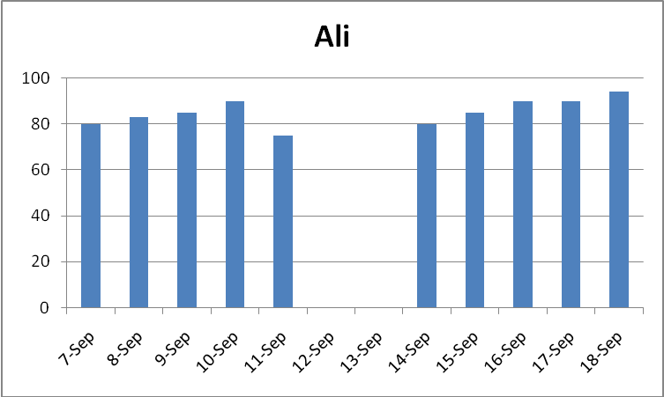

Excel Example B: Line graph of individual student, daily HS-BEP card average for 2 weeks.

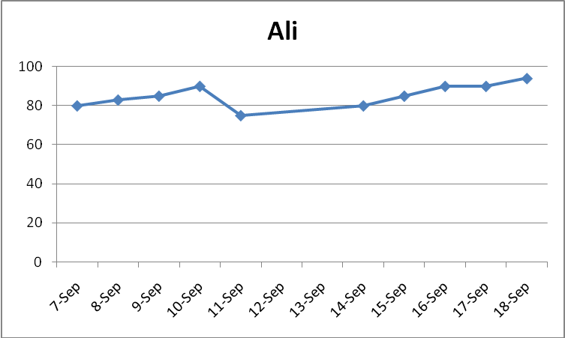

A graph of daily averages can help the HS-BEP teacher, and students, easily identify the days in which the student did and did not meet the 80% goal. Ali is clearly meeting the 80% goal nearly every day in this 2-weel period.

If a student is not making the 80% goal, more information about scores per class periods is necessary for class-specific modifications or supports. Donovan’s example, page 24, shows a graph of daily averages and a graph of class by class scores.

Excel Example C. Bar graph of individual student, daily HS-BEP card average for 2 weeks.

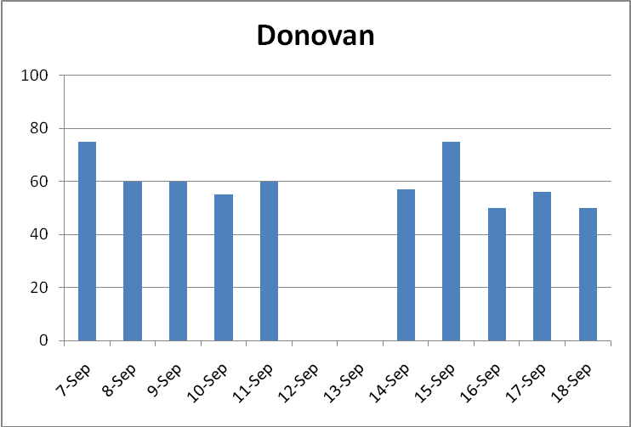

This graph makes it easy to see Donovan is routinely not making the 80% daily goal.

The score per class period graph, below, shows that he has repeatedly earned scores of 0 or 1 in math and science class for the past two weeks. His “problem” classes are easily distinguishable.

Using this information the HS-BEP teacher can gather more information about the specific components of math and science in which Donovan needs more supports.

Excel Example D: Bar graph of individual student HS-BEP scores per class period.

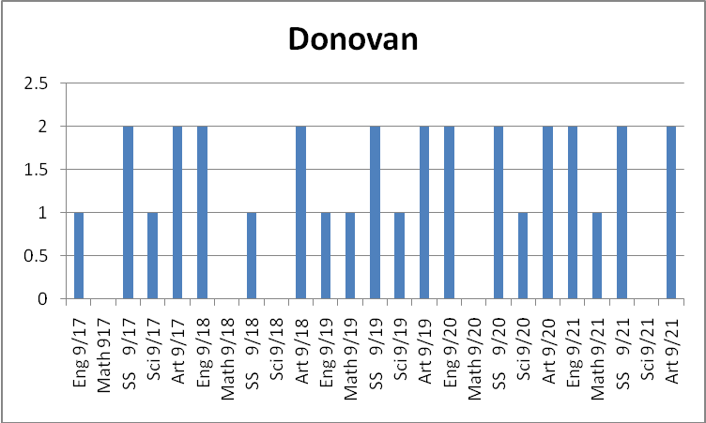
Using School Wide Information System Check-in Check-Out (SWIS-CICO)

Excel and other spread sheet programs provide flexibility in how to display HS-BEP card progress data. They may require double entry of data, averages and daily points, to create graphs that are meaningful for decision making.

If HS-BEP daily averages are the only pieces of information available for progress monitoring it will be more difficult to determine the specific classes in which students need more supports.

The School-Wide Information System (SWIS http://www.swis.org/) has an application for Check-In Check-Out. Teachers can use this application to generate weekly graphs to share with students. There are a range of graphs available in SWIS-CICO. Each graph is available after 1 entry of data: scores are entered by period (see Data Entry Screen). SWIS-CICO calculates daily and by period averages.

SWIS –CICO Example: Main Menu
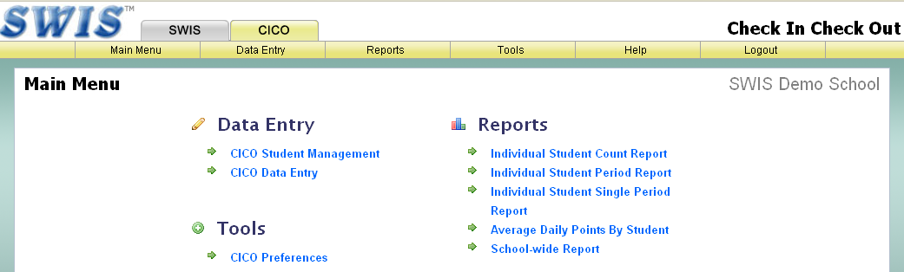

SWIS-CICO Example: Data Entry Screen

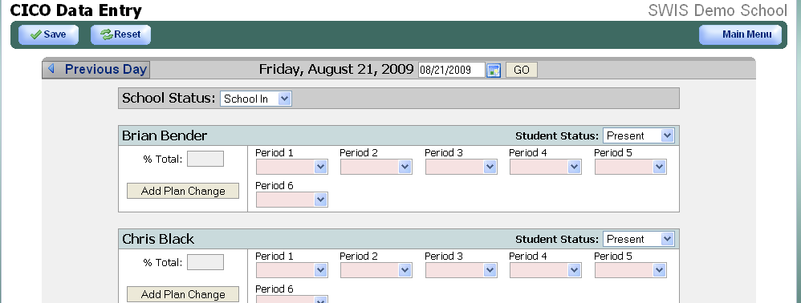

SWIS-CICO Example: Individual student count report: HS-BEP daily averages
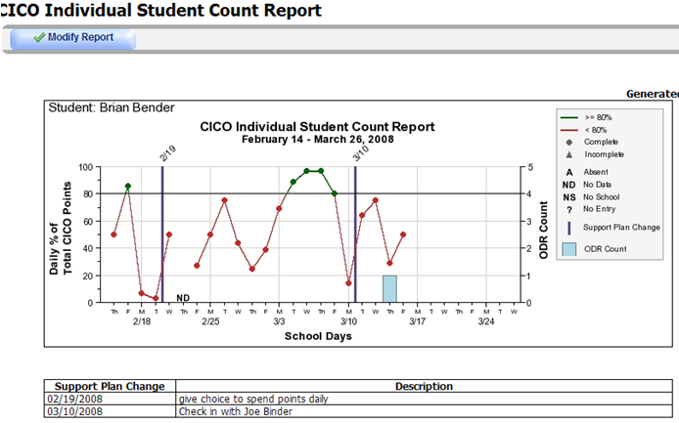

SWIS-CICO Example: Individual student period report: Period averages, days with score per class period.
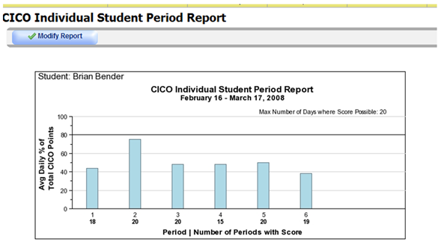
Period # Number of days student has data for each period of the report

The CICO Individual Student Period Report gives you a quick summary of the average scores for each period of the school day, as well as the number of periods in which a student has received a score for a designated number of days (Max Number of Days where Score is Possible: 20).

The Individual Student Single Period Report (below) gives a quick summary of the average score per period but does not provide the max number of days where a score is possible or the total number of days in which a student has a score for each period.

It is important to trouble shoot possible reasons the student is not receiving teacher feedback on the card. It may be as simple as forgetfulness, a rush to get to the next class or lunch. It could also be due to a poor score: students may be less willing to receive teacher feedback when they anticipate a low score. It may also be due to a less than optimal student teacher relationship.

Teacher feedback is paramount in helping students gain awareness of their own behaviors as well as prompting teachers to give positive feedback to students who need additional supports. Identifying the reason a student is not soliciting teacher feedback is important in creating feedback loop from the teacher.

SWIS-CICO Example: Individual Student Single Period Report: Average percent of points earned in one class over several weeks.
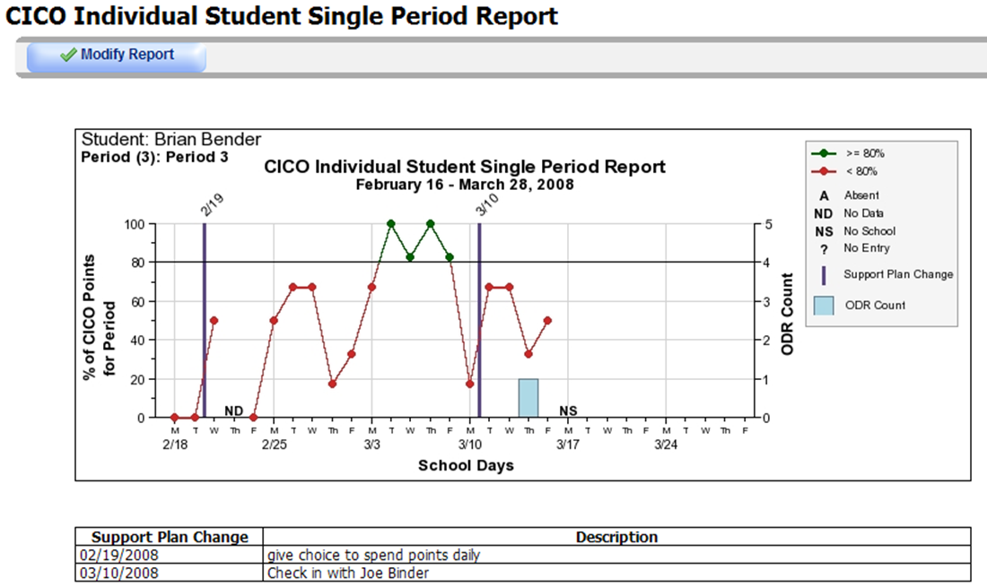

SWIS-CICO Example: CICO Average Daily Points by Student Report: A quick summary of the averages earned by all students participating in the HS-BEP.

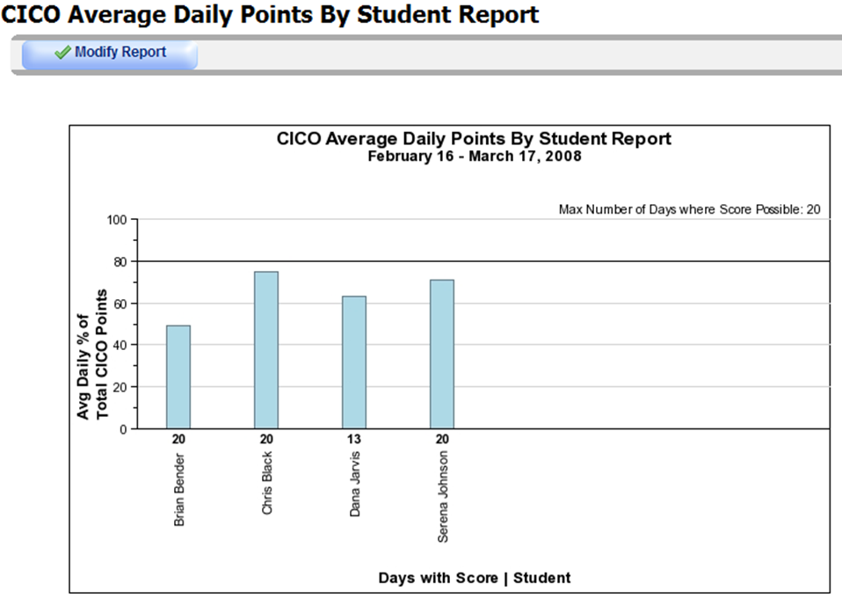

SWIS-CICO Example: CICO School Wide Report: Average and range of all student scores.
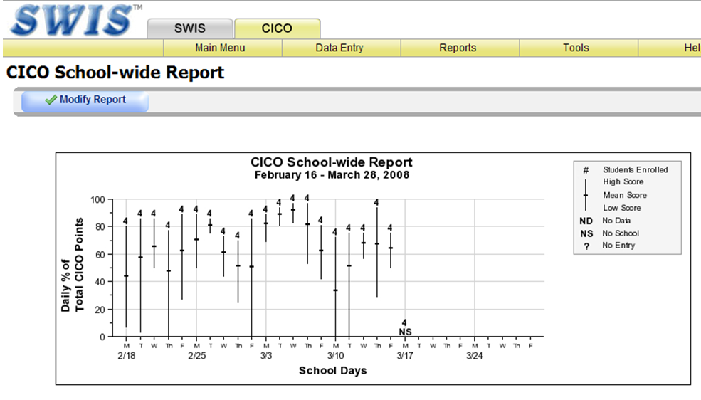
The Average Daily Points by Student Report and the CICO School-Wide Report both give the average score for all students. This provides a quick “snap shot” of the group: is it working for a majority of the students? If it is not working for a majority of the students the school should review a) selection criteria: it Is possible students with incompatible needs have been selected for the intervention, and b) fidelity of implementation: poorly implemented interventions will not meet student needs.

The CICO School-Wide Report also gives the range in scores for the entire group of students. This range in scores allows for a quick picture of how well and poorly the entire group is responding each day. This may be helpful information in predicting “blow out” days as well as rewarding the entire group for meeting the 80% goals.

In the example shown, all students made the 80% goal on two consecutive school days (circled) this would be an excellent opportunity to reward the entire class and may increase motivation to work towards goals more consistently.

Rewards

Tracking student HS-BEP card progress is an essential component for systematic and contingent reinforcement of appropriate school behaviors. Students participating in HS-BEP have more than likely encountered repeated academic and social difficulties in the school setting. Explicit instruction in the academic skills outlined in the HS-BEP curriculum helps build their capacity for meaningful task completion. Increased reinforcement of their positive efforts in the classroom is equally critical in helping them achieve success and reducing at-risk behaviors. Positive verbal and written teacher feedback is the foundation for motivating student engagement. Providing tangible rewards for appropriate school behaviors helps students connect their behaviors with positive school-based outcomes.

As students meet their HS-BEP goals they will receive social and or tangible rewards to further encourage their efforts. Every effort should be made to (a) solicit student feedback on the types of rewards they find appealing, and (b) develop social rewards that increasingly link students to positive peers, teachers, or school events.

Initially rewards may need to be given more frequently to shape positive student behaviors. Students may need rewards for simply remembering to solicit teacher scores, or return the HS-BEP card each day. As students gain fluency in the daily HS-BEP card cycle rewards should be reserved for meeting the 80% criterion. This criterion is met by adherence to the school-wide expectations.

A rewards protocol can further encourage the development of self-management skills. Self managed data tracking and rewards bank (a) requires individual students keep track of the number of days they earn 80% of their HS-BEP points and, (b) allows students to make decisions about how frequently they need rewards. As students meet the 80% criterion they can “cash” in their days, or they can “bank” them for larger rewards. One or two days a week should be designated “cash in” days to limit the number of days the class must dedicate time to reward distribution. For example, the last days of each week can be designated as a “cash in” day. The Academic Seminar teacher can reserve the last 10 minutes of class for students to receive rewards. The Academic Seminar teacher and individual students should keep a record of the rewards earned to document progress. The rewards records can be noted on individual student graphs, goal sheets, or in student planners.

Each HS-BEP class should take time during the first week of class to develop their own rewards bank with the assistance of the HS-BEP teacher. Teachers may already have rewards designated and ask student to identify top 3 choices, or they may allow students to develop a class-specific reward menu. Individual student graphs or student planners can be used to track 80% days. The method of tracking daily points and cashing in for rewards may vary slightly by class but the emphasis of the process is to consistently encourage self-management skills.

An example of a Rewards Bank follows.

REWARDS BANK

- Keep track of the days you make 80% of your HS-BEP points, or your “money days” in your planner.
- Work to make the money days continuous, or in a row. For example: Monday, Tuesday, and Wednesday at 80%.
- Know how many days you need at 80% to get the reward of your choice.
- When you have banked the number of money days required for the reward you want politely notify the HS-BEP teacher during the last 10 minutes of class.
- When the teacher has time to talk with you about your reward you can:
  - Pick from the rewards that match your number of money days, or
  - Chose a reward from any of the lower levels.

MONEY DAY$  (Days at 80%) | ∞ REWARDS ∞
2 | - Capri Sun  - Granola Bar
3 | - Work quietly with peer on homework (during homework sessions only).  - Churchill Lanyard  - Pack of gum
5 | - Pop Corn with a friend and Academic Seminar teacher  - Coffee card
7 | - Choice to use class room computer for assignment
10 | - Lunch with Academic Seminar teacher
14 | - Two coffee cards
18 | - Churchill T-Shirt
23 | - Lunch paid for by the school
30 | - Reduced / free tickets to school sporting event, dance, etc.  - Pizza party for your Academic Seminar Class

Fading, Follow-up, and Exit Criteria

Fading HS-BEP Card

Careful fading of social supports increases the likelihood that students will continue to utilize self-management skills. Once students are reliably meeting 80% of HS-BEP card points for a minimum of 30 continuous days the Behavior Support Team and HS-BEP coordinator will plan to fade supports. The fading process begins with the HS-BEP component. The Behavior Support Team will determine if fading the HS-BEP card is appropriate by reviewing the following data:

- HS-BEP card point totals for the previous 30 days minimum,
- Grades / progress reports
- Attendance, and
- Office discipline records

Teacher agreement Level

If the team determines that the student is making satisfactory progress in the above areas the
student will graduate to the teacher agreement level of the HS-BEP card. On the teacher agreement level, students will:
- Attend Academic Seminar and carry a HS-BEP card,
- Check in and out with the Academic Seminar teacher and carry a HS-BEP card,
- Self-score their class by class performance.

Teachers sign the HS-BEP card if they agree with the self-rating. If they do not agree, they will circle the score they would have, provide positively phrased feedback, and then sign the card.

Independence Level

After three weeks of self-scoring at 90% agreement with teacher perceptions the student can move to independence level. Accurate self-scoring is defined as scores that do not require teacher modifications that lower their daily class room scores. At independence level, the student will:

- Attend Academic Seminar and carry a HS-BEP card,
- Check-in and out with the Academic Seminar teacher,
- Self-score their class by class performance,
- They will not check their scores with the classroom teachers,
- Report their scores to the Academic Seminar teacher during afternoon check-out.

The Academic Seminar teacher will send weekly emails to the student’s teachers to check in with the student’s progress in their respective classrooms. Teachers should note any major behaviors that are interfering with classroom success. In order to move off HS-BEP card completely the weekly email checks should be 100% positive for a minimum of three weeks.

If teachers have concerns about social behaviors the student can stay at independence, move to teacher agreement level, or, if the behaviors are increasing in frequency / intensity, the student may need to return to participating fully in the HS-BEP card.

Once the student moves through both phases of fading successfully by (a) self-scoring with 90% accuracy for three weeks, and (b) self-scoring with 100% positive teacher weekly email checks for three weeks, the Behavior Support Team will review the student records and decide if the progress warrants complete termination of the HS-BEP component.

Fading Guidelines for HS-BEP Card

HS-BEP card Level | Fading criteria | Student  responsibilities | Academic Seminar teacher responsibilities | Class room teacher responsibilities
Full HS-BEP Card | 30 continuous days at 80% of HS-BEP points | - Carry HS-BEP card.  - Solicit teacher feedback for each class | - Provide morning check-in  - Provide afternoon check-out | - Provide scores / comments each period
Teacher agreement | 3 weeks of 90%+ agreement with teacher | - Carry HS-BEP card  - Self-score  - Solicit teacher feedback for each class | - Provide morning check-in  - Provide afternoon check-out  - Check if student self-scores are in agreement with teacher scores | - Check student self-score:  - Initial card if in agreement  - Provide your score in a different color pen if you do not agree with student score and then initial.
Independence | 3 weeks of 90% positive teacher email feedback | - Carry HS-BEP card  - Self-score  - Share HS-BEP card with Academic Seminar teacher one a week | - Provide morning check-in  - Provide afternoon check out  - Email teacher weekly for feedback on student progress | - Respond to weekly emails from Academic Seminar teacher.  - Indicate if you have concerns about student performance,

Exit Criteria from HS-BEP

The Academic Seminar Class should be a semester course for credit. Exit from the class mid-semester is not advisable. Following the fading protocol, outstanding progress in HS-BEP card points for a period of 30 days should prompt the Behavior Support Team to initiate the fading process of the HS-BEP card component only. The student will continue to participate in Academic Seminar. If at the end of the semester the student has shown marked improvement in academic and social markers, such as (a) grades, (b) attendance, (c) office discipline records, and (d) HS-BEP card points, the Behavior Support Team will determine if continuation in the course for the following semester is necessary.

Marked improvement is defined very differently for individual students. A general guideline is to consider if the student’s academic and social behaviors are within the “average” range. Parents/guardians should be notified of the pending decision and encouraged to provide input. Behavior Support Teams should ask the following questions to determine if a student is ready to exit the program completely:

Student progress question | Status | Decision
- Is the student in danger of failing any classes? | Yes | Student should stay in HS-BEP, additional supports may be necessary.
- Is the student in danger of failing any classes? | No | Fading may be appropriate, in consideration of all other student progress data.
- Is the student engaging in problem behaviors that result in (a) removal from class or (b) office discipline referrals? | Yes | Student should stay in HS-BEP, additional supports may be necessary.
 | No | Fading may be appropriate, in consideration of all other student progress data.
- Is the student’s attendance within “average” limits, at or under the maximum limit for the semester? | Yes | Fading may be appropriate, in consideration of all other student progress data.
 | No | Student should stay in HS-BEP, additional supports may be necessary.
- Is the student attending classes regularly? | Yes | Fading may be appropriate, in consideration of all other student progress data.
- Is the student attending classes regularly? | No | Student should stay in HS-BEP, additional supports may be necessary.

Follow Up

It is important to adhere to a follow-up protocol for students who have (a) faded off HS-BEP card and (b) exited HS-BEP completely to ensure continued satisfactory academic and social progress. The following suggestions will help ensure students do not get “lost” when not enrolled in the HS-BEP program.

- The Behavior Support Team / Academic Seminar teacher will keep a list of:
  - Students who have faded from the HS-BEP card
  - Students who have exited HS-BEP.

- Once a month, a Behavior Support Team member or school counselor will monitor academic and social success of these students using a four week progress report, midterm reports and SWIS records (discipline data).

- If a student is not making adequate progress, the student will meet with the Academic Seminar teacher and begin HS-BEP card / Academic Seminar participation within a week of identification through the records review:
  - Failing classes,
  - Office discipline referrals,
  - Skipping classes / lack of attendance

- If students continue to make adequate progress monthly phone calls, emails, or letters will be sent home in recognition of the student’s accomplishments.


Data Collection, Review and Use for Decision-Making

Data-based decision making is one of the most critical components of any school-based intervention. Using data to make administrative or instructional decisions (a) protects students from arbitrary decisions, (b) streamlines the decision making process and, (c) provides documentation for staff and administrative decisions.

Data Collection

Each step of the HS-BEP program requires collection, review and analysis of relevant data. The following table summarizes the sources of relevant information, recommended schedule of collection, and responsible parties.

HS-BEP Phase | Information needed | Schedule of collection | Person(s) responsible
Program Decisions
Identification | - Nomination form  - Grades / academic testing results  - IEP status  - Office discipline records  - Attendance | Once, after student is nominated by staff | Counselor / Designated school personnel
Rewards | Daily HS-BEP card points | Every 48 hours | HS-BEP teacher
Fading / Program modifications | - Semester grades (mid terms, progress reports)  - Attendance records  - Daily HS-BEP card points | Twice each month | HS-BEP teacher
Student progress
Daily Progress | - Grades on learning activities in Academic Seminar class  - Daily HS-BEP card points | - Every 48 hours  - Every 48 hours | HS-BEP teacher
Monthly Progress | - Semester grades (mid terms, progress reports)  - Attendance records | - Every four weeks  - Every four weeks | HS-BEP teacher
Reviewing Data

After classroom and school wide data collection responsibilities are established the Behavior Support Team will meet twice a month to review student progress data and determine if the intervention is having the desired effect: increasing positive academic and social outcomes for participating students. The data review should yield the following information for program and individual decision making:
- The overall number of students:
- Making academic and social gains.
- Not making academic and social gains.
- The areas in which students require more support:
  - Academic
  - Social

Guidelines for reviewing data
- Classroom performance and HS-BEP card data must be updated and reviewed within 48 hours by the HS-BEP teacher
- Academic and social data must be reviewed twice monthly by the Behavior Support Team.
- After students have faded from HS-BEP card / HS-BEP academic and discipline data must be reviewed on a monthly basis by Behavior Support Team member or school counselor.
.

Data for decision-making

For students already participating in HS-BEP, data-based guidelines are necessary for decisions regarding (a) fading supports, (b) exiting the program and (c) modifying supports. It is important that all stakeholders are aware of the guidelines. To the greatest extent possible, adolescent students should be involved in making decisions about their participation in the intervention. Sharing progress data and establishing clear expectations for fading, exiting, and modifications increases predictability of the intervention.

Guidelines for fading and exiting are discussed in the Fading, Follow-up, and Exit Criteria Section. The following guidelines are student progress indicators that should prompt (a) a re-evaluation of student participation, and (b) consideration of program modifications.

Guidelines for decision to modify program
- Five consecutive data points under the 80% goal line that make a flat line or three consecutive descending data points are cause for concern and should prompt a re-evaluation of student progress. (See Olivia B. graph for example of flat line and descending data points).
- Mid-term reports or four –week progress reports that show an increase in classes earning a D or F.
- Teacher feedback that a student is having escalating or increasing levels of inappropriate behaviors in their classroom.
- Student is not attending school at a rate that puts them in jeopardy of violating the district attendance policy.
- Student is skipping class(es) at a rate that puts them in jeopardy of failure or office discipline referral.

Example graph of flat line and descending data points.

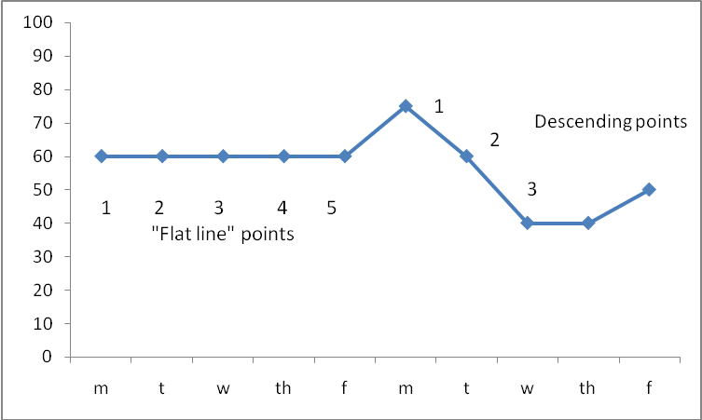
Olivia
% daily HS-BEP Points
80% Goal Line

If the twice monthly data reviews indicate wide-spread lack of success (more than 15-10% of participants not meeting academic or social goals) the Behavior Support Team must determine if (a) the HS-BEP program is being implemented with fidelity, or (b) participating student needs exceed the level of supports available in HS-BEP.

- To determine the fidelity of implementation: a Behavior Support Team member should complete a fidelity check (see HS-BEP Fidelity Evaluation).
- To determine if student needs exceed level of supports: academic testing levels, student and teacher feedback should be compiled by the Academic Seminar teacher.

Modifications

Based on the data review, modest modifications to academic or social supports may be necessary increase student success. Many program modifications can be made within the context of the Academic Seminar classroom by the Academic Seminar teacher: the critical features of HS-BEP program have been found to be essential for maximizing student success. The HS-BEP teacher may need to intensify the frequency or duration of instruction. Depending on the level of student needs, modifications outside of the Academic Seminar program may be necessary to adequately address student needs. Modifications decisions should carefully consider the specific behaviors that require additional supports.

Teacher and student input are critical into the modification process. Because modifications individualize the program for a specific student, any information about the reason for lack of success is helpful in ensuring that modifications match student need. All modification decisions should take into consideration:

- Student’s current level of academic and social performance,
- Student’s input on why she/he is not being successful, and
- Teacher feedback on student’s strengths, weaknesses, and reason for the lack of success.

Some possible modifications matched with reason for lack of success:

Reason for lack of success | Possible modifications
Student lacking basic reading / writing / math skills. | - Target “weak” areas for support in Academic Seminar.  - Peer tutoring within Academic Seminar class.  - Adding supplemental reading / writing / math courses to student’s schedule.
Student not completing daily Academic Seminar learning activities. | - Target “weak” area on goal setting.  - Re-teach / review activities.  - Increase motivation (more frequent / more meaningful rewards).
Student not completing part of the daily HS-BEP card cycle (check-in, class by class check, check-out, home signature). | - Target “weak” area in goal setting.  - Re-teach / review the daily cycle.  - Increase motivation for completing entire cycle (more frequent / more meaningful rewards)
Student has high risk needs. | - Increase level of supports across school day. * Requires individualized, function based supports.

Training Staff & Orienting Students

Staff Training

All faculty and staff must have familiarity with the HS-BEP program to ensure that they (a) utilize the request for assistance (b) accurately complete the HS-BEP card, and (c) know who to contact with student updates. General staff training on the HS-BEP card will take place at the beginning of the school year with boosters in winter and spring. The HS-BEP Card – Class by Class Check matrix and HS-BEP Summary Sheet will be presented to staff during the initial training and boosters.

Big Ideas for Staff Training
- There is a strong relationship between students’ academic successes and problem behavior.
- Students at risk of academic failure benefit from increased structure and encouragement.
- The HS-BEP card reminds students of the school-wide expectations and personal goals.
- The HS-BEP card reminds teachers to “catch” these students following the school-wide expectations.
- The amount of specific, positive verbal feedback students receive during the course of the day is very important in supporting their successes.
  - Recent brain research suggests that adolescents need more reinforcement than adults to acquire similar skills.
- The HS-BEP card should take minimal time to score, add the positive comment, and sign.
- The student benefits are worth the time it takes to provide written feedback and maintain contact with the HS-BEP teachers.
- Frequent communication about class activities helps the Academic Seminar teachers to provide relevant academic supports.

Individual Teacher Contact

During the first week of a student’s participation in HS-BEP, the Academic Seminar teacher will send a generic email to all of the student’s teachers to let them know the student is receiving additional supports. This notification will include brief reminders (see example):

- Student and teacher responsibility summaries
- Contact information for the HS-BEP teacher
- A prompt to make classroom materials available to the HS-BEP teacher.
Example Email to Classroom Teacher

Dear Mr. Horner, I am pleased to let you know that Arleen A. is enrolled in the HS-BEP class. This email is a brief reminder of participation responsibilities.
- Students bring HS-BEP card to each class, hand the card to teacher when they enter the room, retrieve HS-BEP card at the end of class.
- Teachers provide a numeric score, positive written comment and initial the HS-BEP card each class period.

Academic Seminar provides instruction in specific study skills and homework completion assistance while helping students track their classroom behaviors using the HS-BEP card.

I am available by email every school day if you have questions or concerns regarding the HS-BEP card use and student updates. Please feel free to leave worksheets in my mailbox or send me the link to your online classroom resources.

Thank you so much for supporting your students! Ruth Harry, HS-BEP teacher

Orienting Students

The initial orientation for Academic Seminar will take place during the placement meeting with student, Behavior Support Team representative, parent/guardian. The student will be given a copy of the HS-BEP Student handbook.

Once the student begins attending Academic Seminar, the teacher will be responsible for teaching the student classroom protocols for (a) academic activities, and (b) HS-BEP card completion.

Training Academic Seminar Instructors

Teachers who are assigned to instruct the HS-BEP classes must be familiar with (a) the administrative and curricular components of the handbook, and (b) the underlying big ideas.

Teachers must keep in mind that the intention of the program is to proactively increase structure and adult feedback that is focused on students’ adherence to school-wide rules.

This handbook presents guidelines for implementation of critical features of the program, from nomination to fading. These features have been found by the current Academic Seminar Team to be essential for maximizing students’ academic and social success. Modifications to meet individual or group needs are appropriate. However the classroom guidelines, presented in the Teacher Plans section of the handbook should be adhered to consistently regardless of modifications.
Obstacles and Potential Solutions

The following table briefly describes some obstacles and potential solutions for implementing HS-BEP. The potential solutions are suggestions only, based on the experiences of high schools currently implementing the HS-BEP. The unique features of individual high schools can provide a wealth of resources for addressing obstacles.

Obstacle | Potential Solution
Students not consistently carrying / soliciting teacher ratings on HS-BEP cards. | - Target initial goals and rewards on carrying / soliciting teacher rating on HS-BEP card.
Scheduling does not allow for homogenous sections of HS-BEP (separate sections of HS-BEP with and without CICO cycle). | - Heterogeneous student grouping within each section of the HS-BEP classes: non-CICO students engage in daily self rating and the CICO students solicit teacher ratings.
Teachers write negative comments on HS-BEP cards. | - Teacher training on the importance of positive written feedback for students.  - Reward teachers for providing positive written feedback.
HS-BEP teacher is not available for afternoon check out. | - Another adult in the school conducts check out with students (Instructional Assistant, Special Education teacher, coach, etc.) and communicate check-out process to HS-BEP teacher.
HS-BEP teacher is not available for data management. | - Instructional Assistant, or other support personnel, manage student data and communicate data summaries to HS-BEP teacher.
Students demonstrate organizational needs not explicitly included in the HS-BEP curriculum. | - Use students’ organizational needs to supplement HS-BEP curriculum. Examples:  - School based technology,  - Breaking large projects into smaller manageable components,  - “Who’s who” of school adults.
School budget does not allow for a wide range of tangible rewards. | - Brainstorm social rewards already available within the school. Examples:  - Tickets to school sporting events, dances, etc.,  - Preferred seating pass,  - Teacher assistant for a period,  - Lunch with a preferred school adult.

HS-BEP
Teacher Plans

- Class room guidelines
- Curriculum scope and sequence
- Lesson plans
- Student work sheets

Classroom guidelines for the HS-BEP Classroom

The HS-BEP classroom is designed to support the academic, organizational and social needs of students demonstrating secondary level problem behaviors. The curriculum provides explicit instruction in organizational skills while the HS-BEP card adds structure and systematic adult feedback to the students’ school day. With that in mind, the daily classroom protocols must (a) maximize instructional time, (b) create a supportive, predictable environment, and (c) foster self-management skills. The following features are guidelines for the teacher to facilitate student successful in the HS-BEP classroom.
Classroom expectations | - Align with school-wide expectations  - Clearly defined, taught, and reinforced frequently  - Clearly posted in room for reference
Daily Entry Task | - Posted on the board every class period.  - Brief 5-7 minute academic activity.  - Students complete independently upon entering the classroom.  - Activity orients students to lesson at hand, OR, reviews previous skills
Daily Agenda | - Updated and posted every class period  - Includes:  - Daily Entry Task,  - Daily check-in,  - Current day’s activities,  - Schedule of homework completion days for the week,  - Important reminders for the week.
Instructional Activities | - Clear expectations for assignment completion.  - Incorporate students’ interests.  - Scaffolded to meet students’ instructional levels.  - Include rubrics for students’ to self-score assignments before handing in to teacher.  - Include frequent opportunities to respond, review, and practice each skill.  - Instructional decisions based on student progress data.  - Include various modes of response (verbal, written, artistic expression, word processing, etc.)  - Include at least one homework session / week in the first month of the semester, and two homework sessions / week thereafter.  - Utilize student progress data for instructional decision making.
Behavior Management | - Expectations for behavior are taught and reinforced frequently.  - Follow the school-wide model:  - Reminder  - Warning  - Consequence  - Reminder statements for inappropriate classroom behavior:  - State the desired behavior  - Are positively worded,  - Respect the dignity of the student being reminded  - Are followed by verbal praise for appropriate classroom behavior.
Student / Teacher interactions | - Academic Seminar teacher:  - Greets students as they enter the classroom.  - Thanks students for attending and participating at dismissal.  - Has knowledge of students’ interests, strengths and weaknesses.  - Actively supports student’s academic and social efforts by focusing verbal feedback on the positive classroom behaviors.  - Facilitates communication with other staff members to update student participation status and progress.

Weeks | Introduce  (demo / model) | Review/ Practice (guided practice) | Maintain/ Checks (independent work)
1-2 | Class expectations  HS-BEP expectations  HS-BEP Card usage  Planner/ assignment sheet  Goal setting | Each phase of teaching will be guided by student needs. Students should be at 95%+ before moving on to another task.
3-4 | - Goal setting  - Graduation plan  - Tracking progress: progress reports, grades, emailing teachers, action plans | HS-BEP Card  Planner  Goal Setting
5-6 | Notebook organization | Planner  - Goal setting  - Tracking progress | - HS-BEP Card  - Planner
7-8 | Test Prep/Study strategies | - Notebook  - Goal setting  - Tracking progress | - Planner  - Tracking progress
9-10 |  | Test Prep  Study strategies  - Notebook | - HS-BEP Card  - Planner  - Goal setting  - Notebook
11-12 |  | Test Prep | - Planner  Tracking progress  Notebook
13-14 |  |  | - HS-BEP Card  - Planner  - Goal setting  Notebook
15-16 |  |  | - Planner  Tracking progress  Notebook  Test prep
17-18 |  |  | - HS-BEP Card  - Planner  - Goal setting  Notebook  - Test prep
HS-BEP Curriculum Scope and Sequence

HS-BEP, Lesson Plan Format

As with all teaching, student performance should dictate the pacing of lessons, the level of teacher support, and the modes of student responses. The following is the general lesson plan model for the HS-BEP curriculum. Modifications to meet student needs are appropriate.

Prerequisite Skills: This section lists prerequisite skills necessary for completion of the lesson.

The Goal of the Lesson: This section lists the short term goals of the lesson. Specific criteria are included for goals. Long term goals for each skill include routine use of the given skill in Academic Seminar as well as other classes.

Time / Materials: An estimate of the time and materials needed for completion of the initial lesson. Initial lessons can be broken down into two or more lessons depending on level of student needs.

Introduction: This section prompts the teacher to provide a daily agenda and a brief overview of the lesson. The daily agenda include the Daily Entry Task.

Model, Lead, Practice: This section provides:
  - Teacher and student behaviors
  - The critical features of each skill
  - Prompts for teacher to model skills, provide supported and independent practice

Wrap-up: This section prompts the teacher to complete students’ HS-BEP card for the period.

Follow-up Activities: This section outlines multiple learning activities as review or follow-up on the mastered skill. All follow-up activities can be shortened as a Daily Entry Task.

Of Special Note: This section provides important skill specific prompts for teachers. This may
include sequencing review lessons, data use, scaffolding recommendations, etc.

Daily Entry Tasks

Daily Entry Tasks are brief “warm up” activities that function to (a) maximize academic engagement time, (b) orient the student to academic or social behaviors / skills. Example topics are listed below. The example topics cover the range of academic skills found in the curriculum. The Academic Seminar teacher should feel free to improvise topics to meet student need and the academic skill being taught / reviewed.

Guidelines for the Daily Entry Task:
- Posted on the board every class period.
- Brief 5-7 minute academic activity.
- Completed independently by students upon entering the classroom.
- Created to actively orient students to lesson at hand, OR, review previous skills

Example topics for Daily Entry Tasks:
- List upcoming homework and when you will complete the homework.
- List “what’s working” in school.
- List “what’s not working” in school. Write down at least two resources or strategies you can use to improve one of the areas that is “not working”.
- Rank classes from “best” to “worst”. Put the “best” class on the bottom of the list, “worst” class at the top. During today’s homework completion session complete work or study for the class at the top of the list.
- Check the teacher websites for two of your classes. Write down any missing assignments in your planner. Use today’s homework completion session to complete at least one missing assignment.
- Identify a supportive adult in the school. List the characteristics that make this adult supportive.
- List the school rules and at least one example of each of the rules.
- Identify 2 positive experiences you have encountered while using the HS-BEP card.
- Identify one challenge you have encountered using the HS-BEP card. List 2 strategies you can use to overcome this challenge.
- List 3-4 benefits of following the school-wide HS-BEP behaviors in school.
- Give an example of the HS-BEP school-wide expectations that would be helpful in the “real world”.
- Take 5 minutes to complete a notebook check (use the notebook check list).
- Take 5 minutes to check the completeness of your planner. Look through your notebook, backpack, ask a peer, and check the SLC bulletin boards in the classroom.
- Write your most current HS-BEP goal. Are you making progress? Why or why not? If not, what can you today that will help you meet your goal?
- Look in your planner. Do you have a test coming up? List the class it is for, the content on the test, and when the test will take place. Thinking about the study strategies we have discussed, list 2 strategies that work for you. Pick 2 nights between now and the test and plan to use those strategies (write them in your planner!)
- Review your graduation plan. Are you making progress towards your plan? List the steps can you take this week to help you achieve this semester’s requirements.

Teacher Plans for School-Wide Expectations

The Goals of School-Wide Expectations
Students will independently identify, verbally and in writing:
- 3-5 examples of school-wide expectations in at least three school settings (classroom, hallway, cafeteria, etc.)
- 2-4 non-examples of school-wide expectations in at least three school settings (classroom, hallway, cafeteria, etc.)

Time / Materials
45 minutes / written copy of school-wide expectations, paper, pencils,

Introduction: (5 minutes)
- Daily Agenda on the board
- Daily Entry Task: What are the school rules?
- Introduce and describe:
  - We have school-wide expectations or rules for all students, teachers and administrators, they are….
  - These expectations are how we want everyone within the school community to behave and treat one another.
- Solicit student responses on importance or utility of school-wide expectations (creates positive climate)

Model, Lead, Practice: (30 -35 minutes)
Teacher:
- Define school-wide expectations.
- Give examples and non-examples of school-wide expectations in various locations within the school building
- Give examples of school-wide expectations in real world settings. EXAMPLES:
  - Perseverance: If you don’t get the first summer job you apply for, you apply to a second or third until you find a job. Your perseverance will help make sure you can earn money over the summer.
  - Respect: Treating your teacher with respect, by listening while she is giving instructions, is a skill you will use in the workplace by listening to your supervisor. Etc.
- Frequent checks for understanding

Students (verbally and or in writing):
- Reiterate the definitions of the school-wide expectations in their own words.
- Provide examples and non-examples of expectations in at least two school settings

Wrap up: (1-2 minutes)
Teacher:
- Provide HS-BEP card scores for the class period.
- Remind students to follow the HS-BEP card expectations to meet their goals.
- Thank students for participating.

Follow-up Activities: All follow up activities can be modified into a 5-7 minutes Daily Entry Task as needed for review or prompts.

- Student written emails / letters to peers explaining what the school-wide expectations means to that individual.
- Posters that show examples of the expectations:
  - Individually or in groups make posters that exemplify the expectations.
  - One letter at a time or the entire set of expectations.
- Posters advertising the importance of expectations.
- Class discussions or written descriptions of examples expectations students have observed or engaged in during the day.


Teacher Plans for HS-BEP Card Usage

Prerequisite skills
Students must be able to:
- Identify the school-wide expectations with 100% accuracy.
- Identify at least 2 examples and 1 non-example of the school wide expectations.

Time / materials
45 minutes/ HS-BEP card, student and teacher responsibility list, example of HS-BEP weekly graph, achieving 80% goal, example of HS-BEP graph not achieving 80% goal.

The Goal of HS-BEP Card Usage
Students will independently, verbally and /or in writing:
- Describe each step of the HS-BEP Card daily process with 100% accuracy.
- Morning check-in
- Class by class checks
- Afternoon check-out
- Home check
- Give 2-3 non-examples of how to solicit teacher feedback.

Introduction: (5 minutes)
- Daily agenda on the board
- Daily Entry Task: What are the school rules? List 4 behaviors that are examples of following the school rules.
- Introduce and describe:
  - We’re here to work together to build organizational skills and self-awareness to help increase our success in school.
  - The HS-BEP card is going to be a reminder of school-wide expectations and our own personal goals.
  - Helps teachers give us feedback about how we are doing in their class.
  - We’re going to use teacher feedback to shape our behaviors, set goals and increase our success in the classroom.

Model, Lead, Practice: (35-40 minutes)
Teacher:
- Provide step by step description of (a) morning check-in, (b) class by class check, (c) home signature
  - Describe student, teacher, and coordinator responsibilities for each step
  - Use responsibility check lists as reference
- Describe scoring parameters
  - 0 = little to no effort, 1= effort with prompting from teacher, 2=followed all class expectations, no prompting.
- Describe 80% goal
  - All students working towards making 80% of HS-BEP points every day.
  - We will set goals and work towards rewards.
  - Show example / non-example of student graphs
- Frequent checks for understanding
- Provide ample examples and non-examples for soliciting teacher feedback during the class by class checks

Students (verbally and or in writing):
- Reiterate the steps for the HS-BEP card.
- Provide 2-3 non-examples of how to solicit teacher feedback during the class by class checks.

Wrap up: (1-2 minutes)
Teacher:
- Provide HS-BEP card scores for the class period.
- Remind students to follow the HS-BEP card expectations to meet their goals.
- Thank students for participating.

Follow-up Activities: All follow up activities can be modified into a 5-7 minutes Daily Entry Task as needed for review or prompts.

- Role playing activities
  - Examples and non-examples of the check-in/ class by class checks/ check outs
- Posters or written document listing steps to HS-BEP card completion
- Posters or written document showing examples / non examples of HS-BEP card completion
- Posters or written document listing the benefits to using the HS-BEP card
- Class discussions or written description about obstacles AND benefits students have encountered using the HS-BEP card.

Of Special Note ************************************************************
Consistent use of the HS-BEP card is critical to (a) increasing positive student / teacher interactions, (b) providing students with information about classroom behaviors, (c) documenting student progress, and (d) creating and modifying student goals.

Review of HS-BEP card steps should take place at least twice within the first week of HS-BEP card use by the students.

Review of the HS-BEP card steps and problem solving lessons should take place once a month depending on student needs.

HS-BEP Card – Morning Check In
Student Responsibilities | Coordinator Responsibilities
- Report to HS-BEP classroom on time.  - Report to designated check in location.  - Tell coordinator how you’re doing.  - Be honest.  - Return signed HS-BEP Card from home.  - Retrieve new HS-BEP Card from coordinator.  - Complete activities listed on the daily class agenda.  - Take new HS-BEP card to each class. | - Greet and thank student for coming to class.  - Give students new HS-BEP Card, retrieve completed HS-BEP card.  - Ask student how they are doing.  - Check student’s non-verbal signs that may indicate increased risk of negative behaviors.  - Provide structured classroom activities: Daily Entry Task, study skill activities, homework completion time, etc.  - Score students’ performance at and of class.  - Remind student of daily points goal of 80%.  - Convey high expectations of student behavior in a positive way.  - Rate student behavior for the Academic Seminar class period.  - Dismiss to next class  * If student is not ready to be in school (suspected substance abuse, emotional crisis, etc) contact the school counselor, nurse and or administrator to ensure that immediate support is provided to the student.

HS-BEP Card- Class by Class Check

Student Responsibilities | Classroom Teacher Responsibilities
Check In  - Arrive to class on time.  - Give HS-BEP Card to teacher  - Follow class rules, complete assigned work on time.  - Copy assignments into planner / assignment sheet.  - Place class and home work papers in notebook, backpack, etc, in an organized manner (so you can find them later).  Check Out  - Politely retrieve HS-BEP Card from teacher at the end of period.  - Listen to teacher feedback.  - Refrain from negotiating teacher rating  - Report to next class on time.  - Repeat the Class by Class Check process with all classroom teachers. | Check In  - Greet and thank student for coming to class.  - Provide student with:  - positive reminder of daily point goal.  - brief overview of class topic, Big Idea, etc.  - If student is not ready to be in class (visibly upset, suspected substance abuse) contact administrator / counselor immediately to provide additional support for the student.  Check Out  - Thank student for retrieving card.  - Rate student behavior and performance for the class period.  - 2 = Student met goal for the period.  - 1 = Student had a “So so” performance.  - 0 = Student did not meet goal for that period.  - Use positive language to explain rating.  - Praise student for meeting or coming close to goal.  - If applicable, state in positive, explicit terms what student can do to improve performance for next day.  The classroom teachers will need to make classroom materials available to the HS-BEP teacher: worksheets, online resources, schedule of assignments, etc.

Student Responsibilities | Coordinator Responsibilities
- Report to check out location on time.  - Share completed HS-BEP card with teacher.  - Wait for your turn to speak with the teacher listen to teacher’s comments and feedback.  While you are waiting talk with the teacher:  - Update your planner / assignment sheet if needed.  - Check the bulletin boards, check with peers.  - Check that all materials for homework completion are available.  - Stay positive! | - Greet and thank student for returning to check-out.  - One at a time, briefly review student’s day.  - Give specific, positive feedback on student’s performance.  - Convey high expectations of student behavior in a positive way.  - Remind students of their goals for the next day: 80% of HS-BEP points.  - Remind students to check SLC bulletin boards, teacher web-sites, confer with peers on homework, tests and upcoming projects.  - Dismiss for the day  * If student is in crisis, or under escalating stress (suspected substance abuse, emotional crisis, etc) contact the school counselor, nurse and or administrator to ensure that immediate support is provided to the student.

HS-BEP Card – Afternoon Check-Out

HS-BEP Card – Home Check
Student Responsibilities | Parent Responsibilities
- Take HS-BEP Card home to share with parent / guardian  - Ask for parent’s / guardian’s signature on the HS-BEP card.  - Put the card in your notebook, backpack or purse, and bring it to Check In the next day. | - Review the card  - Recognize positive efforts of the student, for example:  “Your score has been at 80% for three days? Great job!”  “You’ve been on time for every class, that is excellent.”  - In a positive way, help student identify what she / he can work on the next school day, for example:  “You did great in English today- you earned a 2. Tomorrow let’s work on earning a 2 in Math by being on time”  “Thanks for remembering to bring the card home. How about tomorrow you work on remembering to have your teachers sign it too?”  “Keep up the good work!”  - Initial the card and add a positive comment. For example:  “Good work!”  “Glad to see Jorge is earning all of his points.”  “How can I support Donovan at home?”  - Prompt the student to return the HS-BEP Card to school.  - Remind the student to put the HS-BEP Card in her/his backpack, homework folder, or somewhere highly visible so it will be remembered the next morning: front of refrigerator, under their house key, etc.

Teacher Plans for Goal Setting

Prerequisite skills
Students must be able to:
- Identify the school-wide expectations with 100% accuracy.
- Identify at least 2 examples and 1 non-example of the school wide expectations.
- Identify 2-3 “teacher pleasing” behaviors (homework completion, participation in class discussion, staying quiet during work completion, raising hand to speak, being on time to class)

Time / Materials
Two 45 minute class periods / paper, pencils, blackboard

The Goal of Goal Setting
Students will independently, verbally and or in writing:
- Identify 1-2 areas of academic and or social needs
- Write an action plan(s) that includes:
  - One problem behavior clearly defined, including setting
  - Two to four ways to redirect that behavior
  - Reward for meeting that goal

FIRST LESSON

Introduction: (5 minutes)
- Daily agenda on the board
- Daily Entry Task: Give two examples behaviors that make teacher’s mad. Give two examples of behaviors that make teachers happy.
- Introduction and describe:
  - Awareness of classroom behaviors is important.
  - Certain behaviors that are considered “teacher pleasing” behaviors.
  - Teacher pleasing behaviors help us get attention and support from teachers for our positive behaviors.
- Solicit student responses:
  - What kinds of behaviors help us be successful in the classroom?
  - What kinds of behaviors get in our way in the classroom?

Model, Lead, Practice: (30-35 minutes)
Teacher:
- Describe the general steps for goal setting:
- Identify behavior that is getting in the way of classroom success.
- List 2-4 ways you can change this behavior.
- Decide the best strategy for YOU to change this behavior.
- Use this information to write a goal that you can track using the HS-BEP card.

    - Provide verbal and written examples for each step of goal setting. For example:
- Behavior getting in the way of classroom success: Talking to my friends during instruction in English class.
- 2 to 4 ways I can change this behavior: Move my seat, ask the teacher to give me non-verbal reminders to stop talking
- A goal for improving that behavior: I will get a 2 on my HS-BEP card in English for the entire week by moving my seat so I don’t talk to my friends during class.

- Dissect an example of goal setting on the board
  - I will get a 2 on my HS-BEP card for ____________ class for ______days by doing ______________________________ so I don’t / I do ______________.
  - “I will get a 2 on my HS-BEP card” should be the first phrase of all students’ goal statements.

Students:
- Turn to your neighbor and explain:
  - The importance of using teacher pleasing behaviors and
  - The steps for goal setting.
- Write the steps for goal setting in your own words.

Wrap-up: (1-2 minutes)
Teacher:
- Provide HS-BEP card scores for the class period.
- Remind students to follow the HS-BEP card expectations to meet their goals.
- Thank students for participating.

SECOND LESSON

Introduction: (5-7 minutes)
- Daily agenda on the board
- Daily Entry Task: Write down the steps to goal setting.
- Brief review of previous lesson
- Today we are going to (a) talk about writing specific goals, (b) write our own goals.

Model, Lead, Practice: (30-35 minutes)
Teacher:
- Demonstrate an example of goal setting based on a generic behavior.
- Provide examples of “fuzzy” v clear problem behaviors
    - “Talking” v “talking during teacher instruction time in English class”
    - “Acting hyper” v “being out of my seat during quiet work time in science
class”
- Provide examples of clearly defined goal behaviors
    - Stay quiet during instruction time in English class for 30 minutes.
    - Stay in my seat for the entire science class, except to sharpen my pencil.
- Use the goal setting activity worksheet as reference
- Provide examples and non examples of “successful” HS-BEP card graphs.

Student (verbally and or in writing):
- Identify 3-4 examples and non-examples of clearly defined goal behaviors
- Write at least 2 clearly defined goal behaviors
- Use the goal setting activity worksheet to document goals

Wrap-up: (1-2 minutes)
Teacher:
- Provide HS-BEP card scores for the class period.
- Remind students to follow the HS-BEP card expectations to meet their goals.
- Thank students for participating.

Follow-up Activities: All follow up activities can be modified into a 5-7 minutes Daily Entry Task as needed for review or prompts.

- Individual meetings every two weeks to determine progress towards goals.
  - If students are making progress towards goal write new classroom goals.
  - If students are not making progress provide additional supports by:
    - creating short term goals,
    - soliciting additional classroom teacher support.
- Written assignments that require the students to re-read previous goal sheets and write follow up notes:
- I did the following things well…
- I still need to work on ….
- Steps I can take to make improvements…

- Written assignments that require students to list 2 positive experiences they have had using the HS-BEP card

Of Special Note ****************************************************************
Goal setting is one of the central features of the HS-BEP curriculum. It is critical that students build fluency in this skill. Review lessons should take place at least once a month. Twice monthly, during a homework completion session, the Academic Seminar teacher should schedule individual meetings with each student to review goals, progress, and consider modifications or next steps for goal setting.



Name____________________ Date______________

Goal Setting Activity
Make a list of:
- Classes that have been positive experiences (good grades, fun teacher, fun activities) classes that have been negative experiences (hard, annoying, no fun).
- The behaviors that get you into trouble in class
- Why you think you do those things (Bored? Is the work too hard? Are friends distracting you?)
- After list is complete, ask yourself if your teachers would agree with you about the behaviors that get you into trouble.
- Pick the behavior that gets you into the most trouble. Brainstorm ways you can avoid doing this (Change seat, get homework done, ask for help).
- Write a goal for HS-BEP based on this behavior.
- Go forth and kick butt (in a very positive way)!

Positive Classes Negative Classes “Trouble” behavior Why?

Would your teachers agree with the behaviors that you said get you into trouble?

What behavior is the biggest problem in classes? How can you avoid doing this?

My GOAL is to achieve 80% of my HS-BEP points by:

These specific behaviors will help me achieve my goal:

- I MET this goal on ____________________.
(DATE)

- I received ________________________ for my dedicate effort.
(REWARD)

Example graphs for HS-BEP card points

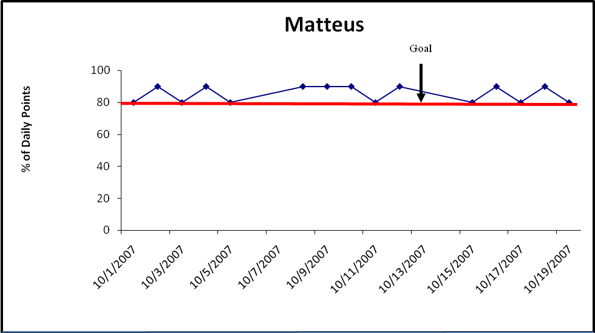

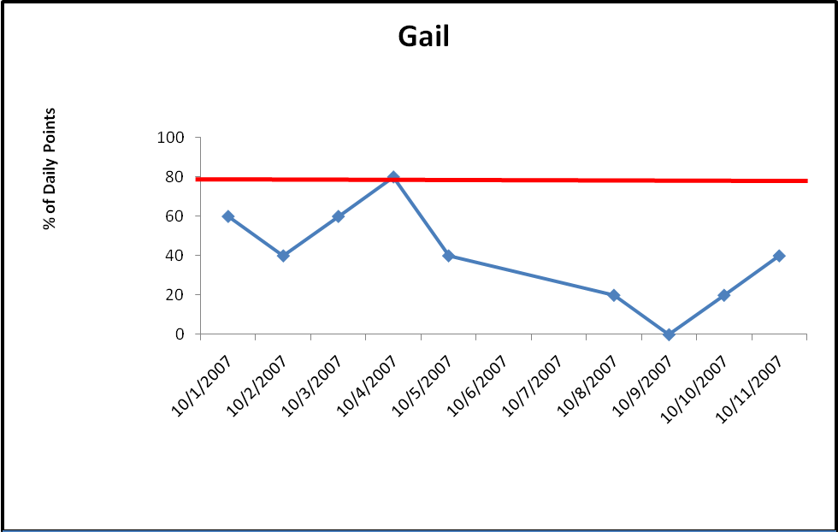

Teacher Plans for Graduation Plan

The Goals of Graduation Plan
Students will independently, verbally and in writing:
- Identify requirements for graduation by class year (freshman requirements, sophomore requirements, etc.) with 100% accuracy.
- Keep their graduation plan in Academic Seminar notebook for the entire semester.

Time / Materials:
45 minutes, 1-2 class periods / copies of the student handbooks for each student, graduation plan template

Introduction: (5 minutes)
- Daily agenda on the board
- Daily Entry Task: Write your most current HS-BEP goal. How are you doing? What are your HS-BEP points for this class / goal?
- Introduction and describe
  - Important to know graduation requirements so can accomplish them in a timely manner.
  - The graduation plan we complete is the same as the requirements shared by counselors during registration / orientation.

Model, Lead, Practice: (30-35 minutes)
Teacher and or school counselor:
- From student handbook read requirements, solicit student readers
- Show example of completed graduation plan
- Ask students to identify requirements
  - For Example: English for four years, PE for four years, etc.
- Show overhead of transcripts “heavy: v “light” load as freshman or sophomores and how that translates to senior year schedules

Students (verbally and or in writing):
- Using the student handbook, identify school credit and class requirements for 9th through 12th grade.
- Complete own graduation plan using template
  - Share with peers / staff
- Put graduation plan in Academic Seminar notebook- first page.

Wrap-up: (1- 2 minutes)
Teacher:
- Provide HS-BEP card scores for the class period.
- Remind students to follow the HS-BEP card expectations to meet their goals.
- Thank students for participating.

Follow up Activities: All follow up activities can be modified into a 5-7 minutes Daily Entry Task as needed for review or prompts.

- Written activity: Review your graduation plan. What do you think will be the easiest to accomplish (classes, grades, requirements)? What parts seem like they will be the most difficult?
- Written activity: Review your graduation plan. Pick one of the challenging classes/requirements and make a list of resources you can use to help be successful in this area.
- Written/ word processed letter to a peer: Write a short letter to an incoming freshman about:
  - Freshman graduation requirements
  - Why it is important to know what classes, credits and projects you have to complete
- Graduation plan review:
  - At midterm / start of the second semester refer to graduation plan.
  - Create 1-3 goals that take into consideration how much progress you have made towards the grade level requirements.
  - Write an action plan to document the specific steps necessary to meet the goals.

Graduation Plan, EXAMPLE


Name: ____________________
School Year: _______________
Grade:____________________

9th Grade Requirements
Classes Credits Completed
____________________________________ ________ ________
____________________________________ ________ ________
____________________________________ ________ ________
____________________________________ ________ ________
____________________________________ ________ ________
____________________________________ ________ ________
____________________________________ ________ ________
Community Service hours:______________

10th Grade Requirements
Classes Credits Completed
____________________________________ ________ ________
____________________________________ ________ ________
____________________________________ ________ ________
____________________________________ ________ ________
____________________________________ ________ ________
____________________________________ ________ ________
____________________________________ ________ ________
Sophomore Project ________
Community Service hours:______________


11th Grade Requirements
Classes Credits Completed
____________________________________ ________ ________
____________________________________ ________ ________
____________________________________ ________ ________
____________________________________ ________ ________
____________________________________ ________ ________
____________________________________ ________ ________
____________________________________ ________ ________
Junior Project ________
Community Service hours:______________

12th Grade Requirements
Classes Credits Completed
____________________________________ ________ ________
____________________________________ ________ ________
____________________________________ ________ ________
____________________________________ ________ ________
____________________________________ ________ ________
____________________________________ ________ ________
____________________________________ ________ ________
Senior Project ________
Community Service hours:______________

Special Notes: ___________________________________________________________
________________________________________________________________________


Teacher Plans for Planner Use

The Goals of Planner Use
Students will independently, verbally and in writing:
- Identify the three steps for planner use, verbally or in writing, 3/3 opportunities.
- Complete 100% of the steps for planner use every Academic Seminar class period.

Time / Materials:
45 minutes / each student must have a planner or assignment sheet, pens, pencils

Introduction: (2 minutes)
- Daily agenda on the board
- Daily Entry Task: How do you keep track of homework, projects, and tests?
- Introduce and describe
  - Using a planner helps us know when assignments are due.
  - Handing in assignments can increase our grades even if we don’t earn high grades on tests.
  - Solicit student responses: What are some real world examples of how planners can be useful?

Model, Lead, Practice: (35-40 minutes)
Teacher:
- Describe the steps for completing the planner / assignment sheet:
    - Listen, locate, log:
    - Listen to the teacher
      - What is the assignment?
      - What are the requirements for completion?
      - When is it due?
    - Locate the date for assignment in the planner, or locate the next section on the assignment sheet.
    - Log, write the assignment and details into the planner
- Solicit student responses to summarize the three steps.
- Provide examples, point out critical information:
  - English literature review (assignment), 2 pages long, story of choice (requirements for completion), due October 4, 2007 (due date).
  - If unsure, unclear, ASK TEACHER
    - What info do we need to know?
    - Solicit student responses (assignment, requirements, due date)
- Provide 3-5 practice examples for the students.

Students (verbally and or in writing):
- Describe the three steps for completing your planner / assignment sheet.
- Complete the practice examples.

Wrap-up: (1-2 minutes)
Teacher:
- Provide HS-BEP card scores for the class period.
- Remind students to follow the HS-BEP card expectations to meet their goals.
- Thank students for participating.

Follow up Activities: All follow up activities can be modified into a 5-7 minutes Daily Entry Task as needed for review or prompts. Some students may use assignment sheets to track assignments. Follow-up activities will need to be modified to include assignment sheets.

- Planner/ Assignment Sheet Update
  - Take 10 minutes to look through your notebook and make sure you have all assignments entered into you planner/assignment sheet. Get online to your teachers’ websites and make note of any missing assignments. Write them into your planner. Write into your planner when you are going to work on those assignments.
- Planner/ Assignment Sheet Benefits
  - Make a list of why it is good to use your planner/assignment sheet. What benefits are there to having your work written down? Share your list with a partner. Together, think of one more benefit (that’s not on either list).
- Planner/ Assignment Sheet Art Project
  - Make a poster of a famous person using their planner. Include steps for using a planner/assignment sheet.
- Planner Scavenger Hunt (in teams)
  - Find the following components of your planner and write down the page number and why that component is important:
    - table of contents,
    - class schedule page,
    - map of school,
    - red day/blue day schedule,
    - cell phone policy
    - study tips section

Planner Swap
- In pairs, students exchange planners and make a list of the positive characteristics of their partner’s planners.
- Positives can include: homework, tests, projects written in on due dates.
- Homework days for Academic Seminar are written in on appropriate days.
- Student schedule is completed with class names, rooms, teacher names, etc.
- Use grading rubric to assign each other a “grade” for the planner.

Example of grading rubric for Planner Swap

 | Easy to find, clearly written | Can find with a little looking, readable | Can’t find or can’t read
Name on planner? | 2 | 1 | 0
Homework assignments written down on due date. | 2 | 1 | 0
Tests written down on due date. | 2 | 1 | 0
Projects written down on due date. | 2 | 1 | 0
Homework days in Academic Seminar written in planner. | 2 | 1 | 0
Student schedule completed for red and blue days. | 2 | 1 | 0

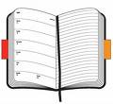

Teacher Plans for Notebook Organization

The Goals of Notebook Organization
Students will independently:
- Write or verbally identify the main components of an organized notebook with 100% accuracy 3/3 trials.
- Organize their notebook using the Notebook Check List.
- Complete monthly notebook checks using the Notebook Check List.

Time / Materials
45 minutes /make sure all students have at least one notebook for academic classes, Notebook Check List for each student or overhead transparency, extra dividers
Introduction: (5 minutes
- Daily agenda on the board
- Daily Entry Task:
- Introduction and describe:
- Solicit student responses: Why is it important to keep your notebook organized?
  - Can find assignments to hand it – get credit
  - Not wasting time looking for items
  - Not get frustrated looking for items
  - Work stays neater
- Today we are going to learn a few simple steps for keeping our notebook organized.

Model Lead, Practice: (30-35 minutes)
Teacher:
- Describe the steps for notebook organization. Use the Notebook Check List as a reference.
  - Section in notebook for each class?
  - Most recent papers on top in each section?
  - Planner / assignment sheet updated with assignments?
  - Throw out papers you don’t need.
  - File papers you do need.
- Request students get out their notebooks and complete the Notebook Check List.
- Circulate the room providing assistance and prompts.

Students:
- Using the Notebook Check List as a “cheat sheet”, describe an organized notebook to a peer.
- Organize class notebook using the Notebook Check List.
- Complete monthly notebook checks using the Notebook Check List.

Wrap-up: (1- 2 minutes)
Teacher:
- Provide HS-BEP card scores for the class period.
- Remind students to follow the HS-BEP card expectations to meet their goals.
- Thank students for participating.

Follow up Activities: All follow up activities can be modified into a 5-7 minutes Daily Entry Task as needed for review or prompts.

- Weekly / twice monthly notebook check up: Take 15 minutes and organize your notebook. Complete the Notebook Check List.
- Exchange notebooks with a friend. Ask them to complete the Notebook Check List and critique your notebook.
- Written activity: Write a 3 minute persuasive speech to a friend about why it is important to keep your notebook organized. Include tips for keeping their notebook organized.

Notebook Check List

Do you have

- A section in your notebook for each subject?

- The most recent papers on top of each section?
- Planner / assignment sheet updated with assignments?

- Papers in the notebook you can throw out? (Double check!)
- Papers you need to put in the notebook?
If you answered “No” to any of the questions take time right now to fix it.



Teacher Plans for Test Taking

Prerequisite skills: Students will need to be able to:

Identify “absolute” words and phrases such as always, never, all the time, forever, etc.
- Define the concept of “key” words or phrases. (Words that provide important information or clues in questions and answers).
- Identify key words and phrases in sample questions and answers.

The Goals for Test Taking
Students will independently:
- Identify the three steps to taking a test with 100% accuracy, 3/3 trials.

Time / Materials:
45 minutes / practice tests, pencils, pens, paper

Introduction: (5 minutes)
- Daily agenda on the board
- Daily Entry Task: How do you feel about taking tests? (Nervous? Okay? Frustrated?)
- Introduce and describe
  - Having a strategy for taking tests makes tests easier to complete and can reduce our “test stress”.
  - Practicing how to take tests you increase your score!
  - Today we’re going to discuss three steps for test taking.

Model, Lead, Practice: (30-35 minutes)
Teacher:
- Describe the three steps for test taking:
  - READ: instructions and questions carefully and thoroughly
  - THINK about important words in the instructions and key words in questions
  - REDUCE: in multiple choice questions reduce the possibilities for answers by avoiding absolutes, eliminating similar answers. On essay or short answer tests reduce time spent on questions by answering or abandoning for the time being.
- Frequent checks for understanding.
- Demonstrate each step of the strategy using a practice test. The practice test should be on subject matter with which the students are familiar. A test they have already completed is ideal.
  - Write RTR at the top of the test as a prompt
  - Talk through each step so students can hear a model of self-talk.
- Solicit responses from students:
  - What are the key words in the questions?
  - What are the key words in the responses? (if multiple choice)

Students:
- Verbally explain the three steps of test taking to a peer.
- In writing, describe the three steps in your own words.

Wrap-up: (1- 2 minutes)
Teacher:
- Provide HS-BEP card scores for the class period.
- Remind students to follow the HS-BEP card expectations to meet their goals.
- Thank students for participating.

Follow up Activities: All follow up activities can be modified into a 5-7 minutes Daily Entry Task as needed for review or prompts.

- One to two weeks prior to midterms review Test Taking strategy, RTR.
- One to two weeks prior to finals review Test Taking strategy, RTR.
- Written / verbal activity: Write or verbally explain RTR to a peer.

Teacher Plans for Study Strategies

The Goals for Study Strategies

Students will independently or in pairs:
- Locate 2-3 websites on study skills.

Write down and share with class 3-5 study strategies that they would be willing to use.

Time / Materials:

45 minutes / internet access for students, pens, pencils, paper

Introduction: (5 minutes)
- Daily agenda on the board
- Daily Entry Task: Do you study for tests? If so, how do you study? If not, why?
- Introduce and describe:
  - Study strategies help you remember important information more easily
  - We all learn in different ways so it is important to find strategies that match how we learn and think.

Model, Lead, Practice: (30-35 minutes)
Teacher:
- Solicit student responses to the Daily Entry Task.
- Write a list on the board of:
  - The way students study.
  - The reasons they do not study.
- Pair students together and ask them to spend 10-15 minutes searching for at least 2 websites that have information about study skills.
- Have student groups:
  - Write down the URL addresses of the study skills websites.
  - Write a list of 4-6 study skills.
  - Briefly (2-3minutes) present study skills to the entire class.
- Keep a running list of study strategies on the blackboard. Omit repeats.
- Ask the students who are listening to:
  - Vote on the 3 study strategies that seem the most reasonable (they would be willing to use them)
  - Write down 3-5 study strategies they would be willing to use
  - Keep a copy of the 3-5 study strategies in their notebook.
- Teacher documents all the study skills presented for review / follow up lessons.

Students:
- In pairs, complete an online search for websites on study skills.
- Write down the URL address so you can return to the website if necessary.
- Look through the websites and make a list of 4- 6 study strategies that seem reasonable (you would consider using them).
- Be prepared to briefly explain the study skills you wrote down. Share why they seem like study skills you would use.
- Be prepared to listen and vote on the top 3 study strategies presented in class.
- Write down 3-5 study strategies you would be willing to use.
- Put the list of study strategies in your notebook for future reference / study sessions.

Wrap-up: (1- 2 minutes)
Teacher:
- Provide HS-BEP card scores for the class period.
- Remind students to follow the HS-BEP card expectations to meet their goals.
- Thank students for participating.

Follow up Activities: All follow up activities can be modified into a 5-7 minutes Daily Entry Task as needed for review or prompts.

- One to two weeks prior to midterms review Test Taking strategy, study strategies.
- One to two weeks prior to finals review Test Taking strategy, study strategies.
- Written activity: Make a list of 3-5 study strategies you have reviewed in class. Share with a friend. See how many you can remember without getting online or looking over your notes.
- Study activity: Get out your notes, books, worksheets, etc and spend 15 minutes QUIETLY reading them over.
- Written activity: Make a list of the things you would need to prepare for an upcoming test. Plan how much time you would need to study and write it into your planner/assignment sheet.
- Written activity: Make flash cards for an upcoming test or quiz. Use colors, pictures and words to help you remember.
- Study activity with peer: Play “Study Pictionary” with a friend. Using pictures only draw vocabulary words, concepts, ideas, etc. for your upcoming test or quiz.
Teacher Plans for Tracking Progress with Technology

Prerequisite skills:
Students must be able to:
- Open and use a word processing program.
- Access the school server.
- Know how to send and receive an email.

The Goals for Tracking Progress with Technology

Students will independently:

Write and respond to 2 teacher emails over the course of the term using classroom appropriate language to (a) request assistance or (b) thank a teacher for her/his assistance.

Log on to school server, locate teacher pages and locate their individual grade page for each of their classes on 3/3 trials.

Time / Materials:
45 minutes for two class periods/ internet access for all students, access to school server for all students, Connections and Communication worksheet, model email soliciting teacher assistance.

FIRST LESSON

Introduction: (5-7 minutes)

Daily agenda on the board
- Daily Entry Task: What class is your favorite and why? What class is a struggle and why?
- Introduce and describe
  - Need a range of computer-based skills in the classroom and in real life
    - Solicit student responses: examples of computer-based skills?
  - It is important to be able to use the school server and teacher web pages as resources for communicating with teachers and keeping track of our progress.
  - We are going to practice emailing a teacher to ask about ways we can improve our grades.

Model, Lead, Practice: (30-35 minutes)
Teacher:
- Describe each step of the activity using the Connections and Communication worksheet for a reference.
- Conduct frequent checks for understanding.
- Present an example of an appropriate email.
- Once you are confident that the students understand the activity assign students to individual computers to begin working.
- Circulate the room frequently to answer questions and ensure the students are on task.
- Make sure you check each student’s letter before they send it to their teacher:
  - Spelling and grammar
  - Appropriate content
  - Request for assistance

Student:
- Using a word processing program (Microsoft Word for example) compose a 3-5 sentence email asking a teacher for ways you can improve your grade in her/his class.
- Make sure teacher reads the letter before you cut and paste it to the email.
- Cut the letter from the word processing program and paste it into the email.
- Send the email, requesting a response.

Wrap-up: (1- 2 minutes)
Teacher:
- Provide HS-BEP card scores for the class period.
- Remind students to follow the HS-BEP card expectations to meet their goals.
- Thank students for participating.

SECOND LESSON

Introduction: (5-7 minutes)

Daily agenda on the board
- Daily Entry Task: What teacher did you email during our last technology class? What actions can you take to start improving your grade in that class?
- Brief review of previous technology lesson.
- Introduce and describe:
  - We can use teacher websites to figure out our grades and if we have missing assignments.
  - This information will help us plan for work completion after school and during homework completion days.

Model, Lead, Practice: (30-35 minutes)
Teacher:
- Describe each step of the activity. Use the Connections and Communication worksheet as a reference if students forget how to access the server / log in.
  - Log onto school server
  - Locate the Staff Page
  - Locate the name of the teacher who teaches the class you emailed last lesson.
  - Click on the name of the teacher you emailed.
  - Click on the My Grades section.
  - Read through your assignments and grades listed on the website.
  - Make a list of 1-2 assignments you are missing or need to make up.
  - Write the assignments into your planner or assignment sheet.
  - Pick a day this week you will complete the assignments either after school or during a homework completion session.
  - Spend the next 25 minutes working on one of the assignments.
- Write the steps of the activity on the board for student reference OR give students a copy of the directions.

Student:

Wrap-up: (1- 2 minutes)
Teacher:
- Provide HS-BEP card scores for the class period.
- Remind students to follow the HS-BEP card expectations to meet their goals.
- Thank students for participating.

Follow up Activities: All follow up activities can be modified into a 5-7 minutes Daily Entry Task as needed for review or prompts.

- Written activity: Read the response email from the teacher. Write down the suggestions for how to improve your grade. Send a brief thank you email.
- Written activity: Based on the response from email from the teacher, create an action plan for how to improve your grade
- Written activity: Email a friend explaining what Academic Seminar does and how they can be successful if they join the class.
- Review activity: Log on to school server. Find your teachers’ websites. Make a list of your current grades in each class. Write down any missing assignments into your planner/assignment sheet. Plan and write into your planner/assignment sheet when you are going to work on those assignments.
- Written activity: Write an email to a teacher about Academic Seminar. Write a second email to a friend about Academic Seminar. What is the same about the emails? What is different? Do you use the same type of words in both emails? Why or why not?

Name: _________________ Period: _________

Connections and Communications
Your goal today is to email one of your teachers to ask them how to improve your grade in that class. Two great things will happen through this process. First, you will make a new connection with a teacher by using a different form of communication (email). Second, you will practice using different technology skills, including:

- Looking up teacher email addresses and websites
- Using the school website
- Using a basic word processing program
- Finding your username and password
- Saving to school server
- Sending an email

Information Needed to Send Email

School Website: www.
The name of the teacher that you will be emailing today ________________________

To get your Teacher’s email address, go to the XHS webpage Staff Page Contact List, and write your Teacher’s email address in the blank below:

Teacher’s email address ________________________

HS-BEP teacher’s email address________________________

For this activity, and all four years of high school, you need to know your username and your password. To find your username, follow these steps:

XHS Students Student Pages Look up your last name…

Write your username in this blank ______________________

Your password is the first two letters of your last name, and the last 4 digits of your student ID.

Write your password here ______________________

Composing Your Email

We will use a general word processing program (Microsoft Word is an example) to compose our email addresses. You will need to first log on with your username and password, because you will save your document to the school server.

Remember: when you are kind and considerate to people, they will reflect that kindness back to you.
- Open up Microsoft Word by clicking on the “W” icon.
- A blank document will open up on the desktop. You can begin writing.
- Start with a polite greeting.
  - Example: Hello Mrs. Cannon, Good afternoon Mrs. Todd, etc.
- Say something nice before you ask for help.
  - Example: I really enjoy your history class. You are a nice teacher, etc.
- Ask the teacher what you can do to improve your grade in her / his class.
- Make sure you tell your teacher that you are willing to work to improve your grade.
- Check your spelling, punctuation and grammar. Your email is a representation of you and your abilities. Present yourself well. You must use SPELLCHECK!
- Ask your teacher to respond to your email.
- DO NOT use text lingo:
  - “You”, instead of “U”
  - “I”, instead of “i”
  - Spell out all words and phrases. Avoid abbreviations, like TTYL and LOL.
- When you are finished click on the save icon or open up “File” and hit save.
- Save the letter as “Email to teacher by (your name).
- The document will save to the school server and can be accessed by logging onto the school server in any classroom, or at home.

Sending your email

- Before you send the letter it must be read by HS-BEP teacher.
- Make sure you have this paper with email addresses, your user name and password on it so you have your teachers’ email addresses and can access your account on GWEN.
- Use your CHS email account to send the letter.
- To use your CHS email account, go to the bottom of any CHS page to where is says 4j District Webmail.
- Click on the link to 4j District Webmail.,
- Log in using your username and password, and press “compose”.
- Follow these steps:
  - Type the teacher’s email address in the box where it says “to”
  - Type in Judy or Melanie’s address in the box where it says “Cc” (You get your grade when we receive your email!)
  - Give your email a “subject” in the subject box
  - Cut and paste your letter that was saved to school server
  - Sign your name and send!

Name: _________________ Period: _________

Tracking Progress Using Teacher Websites

You are going to access the teacher websites to track your assignment completion and start working on missing assignments. Follow these steps to complete the activity:

- Find the Connections and Communication worksheet you completed during the last technology lesson. This will be your reference for username, password, teacher name, etc.
- The name of the teacher you emailed: _______________________________
- Log onto school server
- Locate the Staff Page (on the left hand side menu)
- Click on the name of the teacher you emailed last lesson. This will bring up their website.
- Click on the My Grades section of their website.
- Read through your assignments and grades.
- Make a list of 1-2 assignments you are missing or need to make up.
- Pick a day this week you will complete the assignments either after school or during a homework completion session.
- Write the assignments into your planner or assignment sheet
- Spend the rest of class working on one of the assignments.
- Put this paper in your notebook. You will need it for reference in the future.
- We will be checking progress using teacher websites every week.

Class you are working on: _________________________________________

1) Missing assignment to be made up __________________________________

I am going to work on the first assignment ________________________

2) Missing assignment to be made up _________________________________

I am going to work on the second assignment ________________________

Teacher Plans for Tracking Progress

Prerequisite skills: This lesson builds off the Tracking Progress with Technology lesson. Students will learn several ways to independently track their progress. Emailing the teacher and accessing grades via the school server are important first steps in building self-management skills related to tracking academic progress.

Students must be able to:
- Open and use a word processing program.
- Access the school server,
- Know how to access their grades using teacher websites / school server.
- Identify teacher pleasing behaviors (complete homework on time, participate in class, be on time, etc.)
- Write a goal using the HS-BEP card goal setting protocol. (Goal Setting lesson)

The Goals for Tracking Progress

Students will independently:

Access the school server and teacher websites 3/3 trials.

Identify 1-2 areas of strength and weaknesses as indicated by progress reports with 100% agreement with teacher on 2/2 trials each progress report period (four week period).

Time / Materials:
45 minutes / individual student progress reports, pencils, pens, paper

Introduction: (5 minutes)

Daily agenda on the board
- Daily Entry Task: Take five minutes and look over your progress report.
- Introduction and describe
  - Being aware of our own grades, progress, strengths and weaknesses is powerful. We get to be in charge of our school career.
  - We will be using a range of activities designed to help us stay aware of our progress in classes so we can create action plans to improve our grades.
  - We have already sent teachers emails asking for ways to improve out grades. Today we will be reviewing progress reports.

Model, Lead, Practice: (30-35 minutes)
Teacher:
- Explain that it may be difficult to look at Progress Reports. Thank the students for being willing to work on improving their grades.
- Describe the steps for reviewing Progress Reports:
  - Look over the Progress Reports (5 minutes).
  - Answer the following questions:
  - What classes are going well?
  - What classes are not going well (grade of D or F)
  - What reason is given for the failing grade? (Missing assignments, low test scores, absent a lot?)
  - Is the reason for the D or F the same for every class?
  - Target 1-2 classes for improvement during this next four-week Progress Report period.
  - If the reason for the D or F is the same in each class list 1-2 actions you can take to improve this specific behavior.
  - Make a list of 1-2 actions you can take to improve the reason for the failing grade.
  - Pick a “due date” for the actions and then write them down in your planner or assignment sheet.
- Using an example with identifying information removed, provide example of a Progress Report review and action planning.
- Provide specific examples of actions that would improve: missing assignments, frequent absences / skipping, low test grades.
- Frequent checks for understanding.
- Check in with each student during the period to help them (a) stay positive and (b) brainstorm appropriate actions for grade improvement.

Student:
- Read your Progress Report.
- Identify the classes you are doing well in and the classes you are receiving a D or F.
- Target 1-2 classes for improvement.
- Make a list of specific actions you can take to improve your grade in these classes.
- If the reason for the D or F is that same for all classes create an action plan for improving this reason. For example, if you are failing because you do not complete homework, then create an action plan for completing homework.
- Be prepared to share your plan with the teacher.

Wrap-up: (1- 2 minutes)
Teacher:
- Provide HS-BEP card scores for the class period.
- Remind students to follow the HS-BEP card expectations to meet their goals.
- Thank students for participating.

Follow up Activities: All follow up activities can be modified into a 5-7 minutes Daily Entry Task as needed for review or prompts.

- Computer activity: Log on to school server. Find your teachers’ websites. Make a list of your current grades in each class. Write down any missing assignments into your planner/assignment sheet. Plan and write into your planner/assignment sheet when you are going to work on those assignments.
- Written activity: Check your planner. Have you completed the Progress report activities? Why or why not? What help do you need to accomplish these activities? Ask the teacher if you are unsure.
- Artistic activity: Draw a picture of yourself being successful in a class that is difficult for you.
- Written activity: Write a short story, poem, or rap about yourself being successful in a class that is normally difficult for you.
- Written / computer activity: Email a teacher asking how you can improve a class grade.
- Written activity: Write two academic goals for the semester. Create an action plan including what you need to do and “due dates” for achieving those goals.
- Written activity: Make a list of your classes with the best classes at the bottom of the list, and the worst classes at the top. The classes at the top of your list are your priority for homework completion sessions in Academic Seminar.

Of Special Note***************************************************************
Progress Reports contain confidential information. The teacher must ensure the Progress Reports are securely stored in a locked filing cabinet or desk when they are not being used for the assignment. The teacher must also ensure that students have privacy when reviewing their progress reports. Students should be seated away from one another when they are reviewing the reports.
Some students may feel overwhelmed by looking at their progress reports. The teacher must use positive language to explain that progress reports are useful tools to improve our grades. They are not punitive. With this in mind, the teacher should provide high levels of verbal reinforcement during the lesson. The teacher’s positive comments should target students’ willingness to work on the difficult tasks of self-awareness and planning for success.

Sample self-scoring rubrics for Academic Seminar activities

Academic Seminar Participation
 | Completed on time, according to all directions, neat. | Half way completed, tried but not my best effort. | Didn’t try, couldn’t find, didn’t do.
Daily Entry Task | 2 | 1 | 0
Planner Check | 2 | 1 | 0
Homework completion | 2 | 1 | 0

Daily Entry Task Completion Rubric
 | Heck yeah I did | Tried but didn’t do my best. | Nah.
Followed all directions | 2 | 1 | 0
Completed neatly, organized | 2 | 1 | 0
Used my planner, notebook, etc to see what work I actually had to do. | 2 | 1 | 0

Notebook Organization
 | Sweet | About half way done. | Nope.
Section for each class? | 2 | 1 | 0
Papers neatly organized in each section with most recent items on top? | 2 | 1 | 0
Name on cover? | 2 | 1 | 0
Planner or assignment sheet in the front? | 2 | 1 | 0

HS-BEP GRADING POLICY

Every day you earn a total of 10 participation points in HS-BEP Class. Here’s how…
On time for class | 1 point
Planner  Have it  Up to date with assignments | 1 point  2 points
Daily Entry Task | 3 points
Participating in class activities, homework | 3 points
TOTAL DAILY PARTICIPATION POINTS | 10

All in class assignments will be graded on a 10 point scale. At the end of the semester, all of your daily participation points and in class assignment points will be averaged and multiplied by 10 to give a final grade.

Average of Participation Points + Average of In Class Assignment Points = Final Grade

Example:
1) Add daily points and divide by number of days.

8 (September 10) 49 points / 6 days = 8.16
9 (September 11)
10 (September 12)
7 (September 13)
6 (September 14)
+ 9 (September 17)
49

2) Add in class assignment points and divide by number of assignments:

8 (in class test practice) 44 points / 5 assignments = 8.8
9 (Skills Assessment)
7 (Homework habits)
10 (Planner practice)
+ 10 (Organization work sheet)
44

3) Average daily participation points total and in class assignment totals:
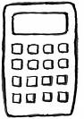

8.16 16.69 points / 2 = 8.48
+ 8.80
16.96

4) Multiply average by 10:

8.48 x 10 = 84.8%

This is your final grade for the semester: 84.8%, rounded to 85%

HS-BEP Card Example, M. Morrison 2008
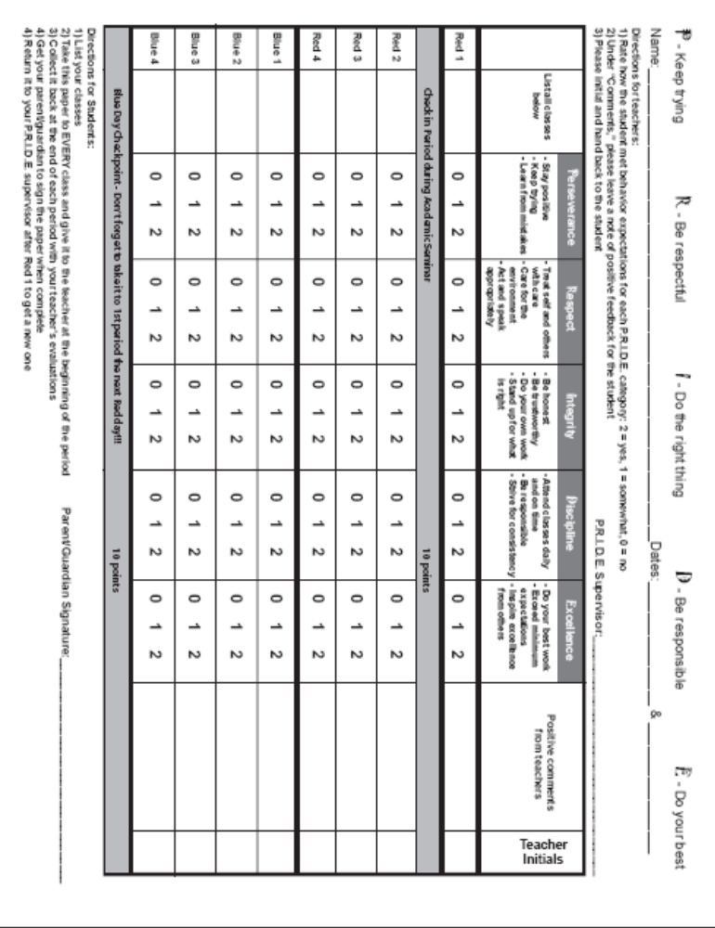

References

Allensworth , E. M., & Easton, J. Q. (2005). The on-track indicator as a predictor of high
school graduation. Chicago: Consortium on Chicago School Research. Retrieved on March 25, 2008 from www.consortium-chicago.org/publications/p78.html.

Jerald, C.D. (2006) Dropping out is hard to do: Issue Brief. Center for Comprehensive
School reform and Improvement. Washington, DC. Retrieved 5-6-07 from www.centerforcrsi.org/files/CenterIssueBriefJune06.pdf

May, S., Ard, W., Todd, A. W., Horner, R. H., Glasgow, A., Sugai, G., et al. (2003). School-
Wide Information System. Eugene: Educational and Community Supports, University of Oregon.

McIntosh, K., Flannery, K. B., Sugai, G., Braun, D., & Cochrane, K. L. (2008).
Relationships between academics and problem behavior in the transition from middle school to high school. Journal of Positive Behavior Interventions, 10, 243-255.

Rumberger, R.W. (2001). Who drops out of school and why. In Understanding Dropouts: Statistics, Strategies, and High-Stakes Testing. A. Beatty, U. Neiser, W. Trent, and J. Heubert (Eds.). Washington, D.C.: National Academy Press.

