- What does the triangle represent to you?  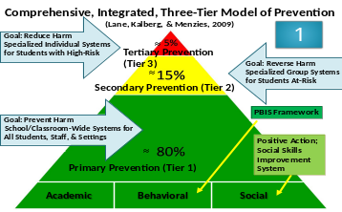 | - What did you learn about the “MATH” and what conversations did you have Day 1 about resources needed to support students? 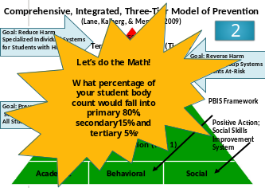
- What does this conversation map mean to you and what were some action steps your schools were considering to implement?  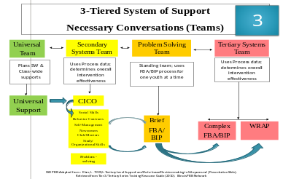 | - What were three big ideas your team took away from the CICO conversation? What are you considering?  

