West Middle School
Check-In/Check-Out Manual

TABLE OF CONTENTS

Page 3 | CICO Intervention Guideline
Page 3 | Purpose of CICO clearly described
Page 4 | Overview of the CICO program
Page 4 | Overview of CICO routine/process
Page 5 | Check in/out staff and location identified (including substitute support)
Page 5 | Student Selection Process  - Data decision rules for screening  - Timeline for access to intervention
Page 6 | Daily Progress Report  - Generic point card linked to positive SW Expectations  - General check-in times identified  - Clearly defined expectations for how to rate student behavior  - Clearly defined process for providing teacher feedback to student
Page 6 | Acknowledgment & point trading system  - Range of incentives  - Documentation of how student progress toward rewards is kept  - Documentation of timeline for delivery of student rewards
Pages 7-10 | Training & Orientation Materials  - Students  - Whole staff overview (e.g., description of CICO, how to access)  - Teacher support when student is on CICO  - Parent Letter  - Substitute teacher information/materials  - Plans for supporting fidelity of implementation
Page 11 | Method for Monitoring Student Progress
Page 11 | Additional Materials

INTERVENTION GUIDELINE

Intervention | Description | School-wide Data: Entry Criteria | Data to Monitor Progress | Exit Criteria
Check-In/Check-Out | -Relatively easy and quick to implement for up to 10-15% of all students.  -Adult checks in/out with multiple students (5-10 students)  -All youth get same intervention  -Same check-in/out time  -Same SW behavioral expectations as goals  -Same Daily Progress Report (Cool Card)  -Student receives opportunity for positive adult interactions  -Parents participate by signing Cool Card | To be considered data must meet two out of the following areas:  -Academic & behavior concerns which look like:  - Screening score in moderate-risk range on the SRSS,  - Three or more ODRs in a trimester  - Two or more out of school suspensions  - Failing 2 or more core academic classes  - 3 or more unexcused absences  AND  -Function of student behavior related to seeking attention | -Daily progress monitoring forms (Cool Cards) completed by teachers and viewed by parents  -Reduction in ODRs (during given time)  -Improved Grades  -Improved Attendance  Data Example:  After 6 weeks, 28 of the 33 students earned 80% or more points on their Cool Card, and there has been a 50% reduction in total ODRs for these 33 students. | -Move into maintenance self-monitoring phase when students meet their goals for 3 consecutive weeks  -Maintenance may end at next grading period

Rationale

The CICO Program is a check-in, check-out prevention program for students who are engaging in low level problem behavior. The goal of the CICO program is to prevent students who are acting out from escalation and provide them with more frequent feedback on their behavior to prevent future problems.

Overview of CICO (Routine & Practices)
How do teachers participate?
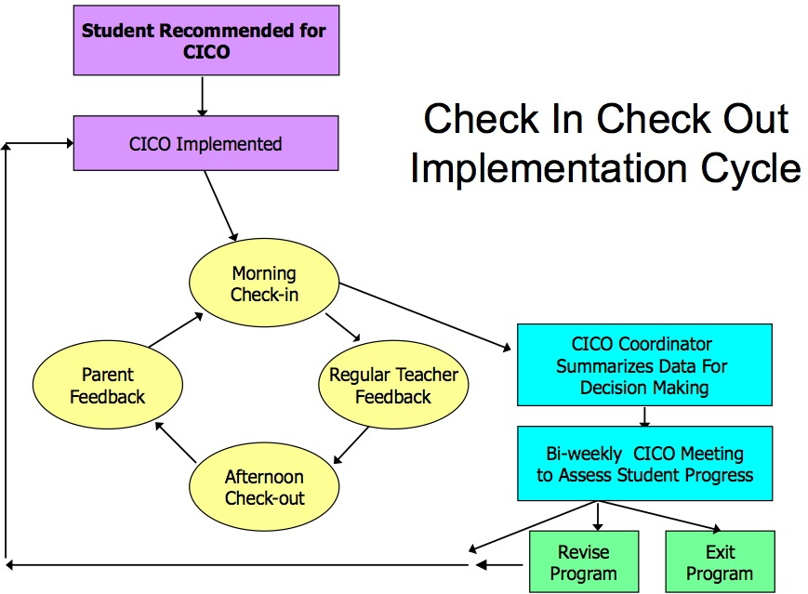
Teachers participate by providing both verbal and
written feedback to students at pre-determined
times throughout the day. The feedback is quick
and instructional.

Who is responsible for checking students in and out?

A dedicated teacher is in charge of checking their adopted students in and out on a daily basis. Check-in would happen in the morning before/during the first block with check-out occurring at the end of the day in AE or 4th Block for 6th Grade.

What role do students have in monitoring their own behavior?

Students will be responsible for monitoring their own behavior throughout the day. Students will receive feedback from teachers/mentor appropriately.

What is the family’s role?

The daily Cool Card will be sent home to the parent. The student is encouraged to show the Cool Card to parents and get a signature to return to school during the next day check in. Families are encouraged to acknowledge their child’s efforts and success and to refrain from punishment when their child temporarily slips up. A weekly check in with the child’s mentor is highly encouraged.

What role does the counselor play?

The counselor will keep track of the daily points earned and charts the progress of each student. If a student is getting 80% or more of daily possible points (48/60), they are being successful. On a bi-weekly basis, the counselor & Tier 2 Support Team meet and contact the teacher participant and discuss whether the program for their adopted student should stay the same, be adjusted, or be terminated. When progress has a downward trend for three days or more, the counselor will review the data and program and make adjustments as needed.

CICO STAFF
Check-in/Check-out Coordinator: Steve Smith
Responsibilities:
- Provide teachers with extra DPR copies
- Calculate percentages and graphs
- Be encouraging with students, give student feedback and suggestions on how to modify behavior resulting in more goal completion
- Be organized and dependable
- Communicate CICO progress data at Tier 2/3 monthly meetings
- Monitor Social Validity & Treatment Integrity of CICO Intervention
- Orient teachers, students and staff regarding CICO

STUDENT SELECTION PROCESS

Data Decision Rules: To be considered data must meet two out of the following areas:

-Academic & behavior concerns which look like:

- Screening score in moderate-risk range on the SRSS,
- Three or more ODRs in a trimester
- Two or more out of school suspensions
- Failing 2 or more core academic classes
- 3 or more unexcused absences

AND

-Function of student behavior related to seeking attention

DAILY PROGRESS REPORT

1 = Try Again  2 = Good  3 = Excellent | Positive  Follow Directions | Safe  Stays In Seat | Responsible  On Task | Respectful  Teacher & Others | Teacher  Initials
Block 1 | 1 2 3 | 1 2 3 | 1 2 3 | 1 2 3
Block 2 | 1 2 3 | 1 2 3 | 1 2 3 | 1 2 3
Block 3 | 1 2 3 | 1 2 3 | 1 2 3 | 1 2 3
Block 4 | 1 2 3 | 1 2 3 | 1 2 3 | 1 2 3
Academic Excellence | 1 2 3 | 1 2 3 | 1 2 3 | 1 2 3
Comments:

Total Points

ACKNOWLEDMENT SYSTEM

What are the incentives for students completing Goal Sheet and being Successful?
Each time a student checks-in/out & returns a parent signed Cool Card their Star Student card should be marked or punched. When the card is full the student may exchange the card for an incentive.

TRAINING & ORIENTATION MATERIALS

Staff Training Materials
http://pbistier2.weebly.com/uploads/1/2/7/0/12709910/cico_saff_training_template.ppt
Hello Teachers!

I wanted to give you information related to the Wild CATS Check-In/Check-Out Program. First, thank you for giving your time and effort in participating in this program. On Thursday during AE I plan to speak with each student participating in the program. I will be going over the student contract with the student as well as conducting a brief training on how to manage teacher and parent feedback with the Cool Card. At the end of AE on Friday, when the 1st Bell rings, the student you were assigned to check-in and out with you will be stopping back to check-out with you and to drop off their signed student contract to be placed in their folder. Please use this brief time to introduce yourself and answer any questions your student may have. This is a good time to let the student know that you will be looking forward to seeing them Check-In with you on Monday before the start of 1st Block.

Wild CATS stamps – Please remember to give a stamp each time your student Checks-in and out with you and when a student They should write their name on the back of the ticket and place it in the plastic jar outside my office.

The following is the list of students who are participating along with the assigned teacher to that student:
6A Students |  | 6B Students
Student | Teacher | Student | Teacher
 | Coleman |  | Beale
 | Spotanski |  | Emelander
 | Pearce |  | Parker
 | Rizzo |  | Frankenberger
 | Wiggs |  | Williams
 | Kelly |  | Ragsdale
 | Perkins |  | Fonseca
 | Courtney |  | Corey
 | Klouse |  | Tepen
 | Heilweck |  | Johnson

Additionally, please turn in the Student Account Record at the end of each week. I will be completing data for each student. If you need more of the COOL CARDS I will have them outside my office for you to pick up. If there are any questions, comments or suggestions please do not hesitate to let me know.

Student Orientation Materials
CICO Student Agreement

Much of your success in CICO depends on you. The CICO student agreement is designed to ensure that you understand your role in CICO.

Carefully read each statement. For you to succeed in CICO, we ask that you fulfill the CICO student requirements. We are striving for this to be a positive experience for you both at school and at home.

Please initial each requirement to indicate that you have read and understand the requirement. A copy will be made for you.

_____________ I will check in EVERY morning with my Mentor between _____________.

_____________ I will check in EVERY afternoon with my Mentor between ____________.

_____________ I will have ALL of my teachers complete my CICO Card in my classes EVERYDAY

_____________ I will take the CICO CARD home to be signed by my parent/guardian EVERYDAY

_____________ I will come prepared each day for school including returning my CICO CARD, completed homework, pencil, planner and other supplies as needed.

_____________ I will let my Mentor know if there are any concerns or problems that I am having, so we can take care of them as soon as possible.

I understand CICO student requirements, and will do all that is required for me to be successful participant in the CICO program.

__________________________ __________________________ _______________
Student Name (please print) Student Signature Date

Parent Orientation Materials
Dear Parents/Guardians,

I am excited to inform you that your child has been chosen to participate in a program titled, _______________”.

The goal of this program is to support students who have been identified as needing a little extra help in following our four school-wide expectations and thus allowing them to experience greater academic success. This program has been developed to assist your student with acceptably handling the types of behaviors that may be causing his/her lack of success.

The CICO program’s goal is to assist your student by providing
- Support for them academically
- Daily positive adult interactions
- Personal monitoring and assistance to help them modify his/her own behavior
- Direction to develop organizational and study skills.

We are very excited about this new program and believe that it will have a positive impact on your child. We are hopeful that this program will encourage your child to enjoy the overall learning environment provided at our school.

This program not only provides additional adult support for your student; it also provides a more positive outlook about coming to school everyday. Finally, we hope to make a more positive connection for your student, between adults at home and staff at school.

We are planning to start this program on __________________. Please take the time to go over your child’s CICO Card chart that evening so that you both understand how the program works. If you have any questions or would like additional information about the program please feel free to contact _________________ .

Sincerely,

Overview of Check-in/Check-out Program

- Your child will start and end each day by meeting briefly with a specifically identified staff member who will be assigned to work with your child.

- Each morning you child will “Check-in” and get a daily cool card chart that will help them to remember to follow the four school-wide expectations: Safe, Positive, Responsible and Respectful.

- Your child will also pick one specific goal to work on each week. Our staff will indicate on this chart how your child does throughout the day.

- Each evening, your child will “Check-out” with the same teacher, who will assist him/her in making sure he or she has everything needed to complete homework assignments.

- His/her CICO Card chart will be reviewed daily. Each day your child will bring the CICO Card report home detailing their goal for the day, how they did and what they will work on the next day. Please sign and have your child return at “Check-in” the following day.

- Your support will help reinforce these expectations at home as well as at school.

Please sign and return:

My child ____________________________________________has permission to participate in the Check-in & Check-out Program

_____________________________ ________________________

Substitute Teachers Orientation Materials

MONITORING STUDENT PROGRESS

ADDITIONAL MATERIALS

